SEPA environmental checklist

Purpose of checklist:

Governmental agencies use this checklist to help determine whether the environmental impacts of your proposal are significant. This information is also helpful to determine if available avoidance, minimization or compensatory mitigation measures will address the probable significant impacts or if an environmental impact statement will be prepared to further analyze the proposal.

Instructions for applicants:

This environmental checklist asks you to describe some basic information about your proposal. Please answer each question accurately and carefully, to the best of your knowledge. You may need to consult with an agency specialist or private consultant for some questions. You may use “not applicable” or "does not apply" only when you can explain why it does not apply and not when the answer is unknown. You may also attach or incorporate by reference additional studies reports. Complete and accurate answers to these questions often avoid delays with the SEPA process as well as later in the decision-making process.

The checklist questions apply to all parts of your proposal, even if you plan to do them over a period of time or on different parcels of land. Attach any additional information that will help describe your proposal or its environmental effects. The agency to which you submit this checklist may ask you to explain your answers or provide additional information reasonably related to determining if there may be significant adverse impact.

Instructions for Lead Agencies:
Please adjust the format of this template as needed. Additional information may be necessary to evaluate the existing environment, all interrelated aspects of the proposal and an analysis of adverse impacts. The checklist is considered the first but not necessarily the only source of information needed to make an adequate threshold determination. Once a threshold determination is made, the lead agency is responsible for the completeness and accuracy of the checklist and other supporting documents.

Use of checklist for nonproject proposals:

For nonproject proposals (such as ordinances, regulations, plans and programs), complete the applicable parts of sections A and B plus the supplemental sheet for nonproject actions (part D). Please completely answer all questions that apply and note that the words "project," "applicant," and "property or site" should be read as "proposal," "proponent," and "affected geographic area," respectively. The lead agency may exclude (for non-projects) questions in Part B - Environmental Elements –that do not contribute meaningfully to the analysis of the proposal.

A. Background [help]

1. Name of proposed project, if applicable: East Fork Trail UNT3 Re-route Stream Crossing

2. Name of applicant: Erin McKay

3. Address and phone number of applicant and contact person: Address: 411 Washington St., Suite 201 Wenatchee, WA 98801 Phone: (509)630-5303

4. Date checklist prepared: 1/10/22

5. Agency requesting checklist: WDFW

6. Proposed timing or schedule (including phasing, if applicable):
Stream crossing will be built in summer 2022. There are no in-water work timing restrictions, so work will occur between May and October 2022 when conducive to overall trail building plan.

7. Do you have any plans for future additions, expansion, or further activity related to or connected with this proposal? If yes, explain.
No, there are no plans for expansion of this project in the future.

8. List any environmental information you know about that has been prepared, or will be prepared, directly related to this proposal.
There was an Environmental Assessment prepared for the trail location, including the proposed crossing. The Environmental Assessment underwent a formal NEPA process in 2020-2021, resulting in a FONSI (finding of no significant impact) signed by the Wenatchee River Ranger District of the Okanagon-Wenatchee National Forest in November 2021. NEPA documents including the final EA and Decision Notice can be found on the USFS SOPA site here: https://www.fs.usda.gov/project/?project=58880

9. Do you know whether applications are pending for governmental approvals of other proposals directly affecting the property covered by your proposal? If yes, explain.
No other applications are pending for other proposals affecting the property.

10. List any government approvals or permits that will be needed for your proposal, if known. The overall trail re-route will require a SUP (USFS Special Use Permit), and the crossing will require a WDFW Hydraulic Project Approval, an Army Corps permit for minor fill with an associated 401 Water Quality Certification from WA Dept of Ecology.

11. Give brief, complete description of your proposal, including the proposed uses and the size of the project and site. There are several questions later in this checklist that ask you to describe certain aspects of your proposal. You do not need to repeat those answers on this page. (Lead agencies may modify this form to include additional specific information on project description.)
This project entails the re-route of ~3 miles of a popular recreation route in the vicinity of the Devil’s Gulch trail system in the Mission Creek drainage south of Cashmere, Washington. The purpose of the trail re-route is to remove recreation use from the valley floodplain of East Fork Mission Creek, where it is currently degrading ESA listed steelhead habitat and contributing to sediment delivery and floodplain incision. The new single-track, multi-use trail alignment stays entirely out of the floodplain of East Fork Mission Creek by traveling up adjacent Peavine Canyon and crossing a minor ridge to rejoin FS 7100 for the climb to the top of Devil’s Gulch trail. The new trail alignment requires one stream crossing of an unnamed, intermittent tributary to East Fork Mission Creek (referred to as UNT3 in the Environmental Assessment). The crossing will consist of a hardened ford created by placing 6” angular rocks into the stream channel with a defined low point for water passage, maintaining current elevations. The rocks will protect the stream banks from erosion, and will extend ~2’ outside of Ordinary High Water on either side of the stream to add bank protection.
UNT3 is located in a scrub-shrub slope wetland in a small swale. The trail development will require clearing of brush in the wetland. Downed trees and logs existing on site will be used as borders along the trail edges through the wetland area to prevent encroachment of the trail. Any impacts from the construction of the trail and stream crossing in this area will be more than compensated for by removing recreation use from the floodplain of East Fork Mission Creek, where motorcycles and mountainbikes regularly cross at least 12 unprotected stream crossings through steelhead habitat.

12. Location of the proposal. Give sufficient information for a person to understand the precise location of your proposed project, including a street address, if any, and section, township, and range, if known. If a proposal would occur over a range of area, provide the range or boundaries of the site(s). Provide a legal description, site plan, vicinity map, and topographic map, if reasonably available. While you should submit any plans required by the agency, you are not required to duplicate maps or detailed plans submitted with any permit applications related to this checklist.
The project is located at approximately the 8 mile mark on FS 7100. At approximately mile 5 of FS 7100, accessed from Cashmere, Washington, the road becomes impassable to vehicles due to a large earthen berm and a stream crossing. Continuing up FS 7100 on foot or bike, the project area is reached after 2.8 miles, once the old road bed leaves the floodplain. Travel up and over the small ridge to the north of the road, and drop down into the small valley to the project area. The project is located in T22N R19E S34, SE ¼ Section, at lat-long 47.351828N -120.431472W. A map is included with this checklist.

B. Environmental Elements [help]

- Earth [help]

a. General description of the site:

(circle one): Flat, rolling, hilly, steep slopes, mountainous, other _Flat, valley bottom_____

b. What is the steepest slope on the site (approximate percent slope)?
The site of the stream crossing is very low-angle, with a slope percent less than 5%.

c. What general types of soils are found on the site (for example, clay, sand, gravel, peat,
muck)? If you know the classification of agricultural soils, specify them and note any agricultural land of long-term commercial significance and whether the proposal results in removing any of these soils.
The geology of the area is generally sandstone, with primarily sandy soils and sandstone bedrock. The valley bottom where the stream crossing is located is denser, clayey soil with high moisture content but no standing water.

d. Are there surface indications or history of unstable soils in the immediate vicinity? If so,
describe.
No surface indications of unstable soil in the immediate vicinity.

e. Describe the purpose, type, total area, and approximate quantities and total affected area of any filling, excavation, and grading proposed. Indicate source of fill.

A small amount of fill will be placed within the stream channel of UNT 3 to protect the streambed from erosion caused by recreational crossing of mountain bikes and motorcycles. A small amount of material will be excavated from the stream banks and extending a few feet on either side of the stream to allow placement of 6” angular rocks for surface protection. The rocks will be placed flush with the streambanks above and below, as well as the stream channel. The stream channel is 24-36” wide at the location of the crossing. Rock protection will have about a 4’ width to match the trail leading up to it, and will be about 9’ long at the most (3’ on either side of the stream, and 3’ max stream width). Total surface area of the rock placement will be about 36 sq. ft., and total excavation/fill will be approximately 18 cubic feet, or less than 1 cubic yard. Fill may be sourced on site or will be sourced from a local quarry.

f. Could erosion occur as a result of clearing, construction, or use? If so, generally describe.

Erosion could occur if water were running through the project area during excavation, such as from stream flows or intense precipitation events. However, any existing stream flows will be diverted from excavation areas, and work will not commence if there is adverse weather forecast, so erosion should not occur from excavation activities. Once in place, the rocks will not cause erosion as they will be placed to match the contours of the existing stream bed.

- About what percent of the site will be covered with impervious surfaces after project
construction (for example, asphalt or buildings)?

100% of the actual trail stream crossing will be covered with rock to protect from erosion. However, water will be able to saturate through rock as needed, and stream flows should not be affected by presence of rock. The area covered by rock represents a tiny fraction of the total project area of the new trail construction.

- Proposed measures to reduce or control erosion, or other impacts to the earth, if any:

The rock will be placed flush with the ground/streambed surface to prevent erosion from around the rocks. All excavation work will be completed “in the dry”, with any streamflows diverted around the area during excavation/placement of rock. Any exposed soil following project completion will be covered with locally available mulch to help prevent erosion.

2. Air [help]

- What types of emissions to the air would result from the proposal during construction, operation, and maintenance when the project is completed? If any, generally describe and give approximate quantities if known.
Emissions caused from project construction would be limited to the vehicle used to access the site and carry in quarry rock. The work will be done by hand, and there will be no emissions during excavation, placement, or any other activities associated with the construction of the stream crossing.

- Are there any off-site sources of emissions or odor that may affect your proposal? If so,
generally describe.
No off-site sources of emissions are anticipated with this project.

- Proposed measures to reduce or control emissions or other impacts to air, if any:
No need to reduce or control emissions as there are very minimal emissions associated with the project.

3. Water [help]

a. Surface Water: [help]

- Is there any surface water body on or in the immediate vicinity of the site (including
year-round and seasonal streams, saltwater, lakes, ponds, wetlands)? If yes, describe type and provide names. If appropriate, state what stream or river it flows into.

The trail will cross an un-named intermittent stream that is referred to as UNT 3. The stream is likely spring fed and originates around a mile upstream from the project area. The stream flows into the East Fork Mission Creek about 100 yards downstream from the project area. The stream does not support andromedous fish habitat due to a steep rocky drop located near the confluence with East Fork Mission Creek. According to the EA prepared for the trail re-route, the stream is not likey to support fish habitat at all, but is likely to support other aquatic organisms. The stream flows through a valley bottom scrub/shrub slope wetland.

- Will the project require any work over, in, or adjacent to (within 200 feet) the described waters? If yes, please describe and attach available plans.

Yes, the project will require work within the described intermittent stream and wetland. The trail will cross through the wetland, which will require clearing of shrubs and other vegetation (no trees will be removed). The stream crossing itself will require work within UNT 3.

3) Estimate the amount of fill and dredge material that would be placed in or removed
from surface water or wetlands and indicate the area of the site that would be affected.
Indicate the source of fill material.

Less than 1 cubic yard will be excavated from the stream channel of UNT3, and less than 1 cubic yard of fill will be placed within the stream channel of UNT3 to replace the material that is excavated. Native material will be excavated, and locally sourced (either on-site or from a local quarry) 6” angular rock will be placed within the stream channel to create a hardened surface.
An estimated 16 cubic yards of crushed rock will be placed on top of wetland surface, between timber cribbing to create the raised trail surface. This will cover an estimated 650 square feet in the trail alignement across the valley-floor wetland associated with UNT3. The crushed rock will be sourced from a local quarry. No excavation will occur within the wetland.

4) Will the proposal require surface water withdrawals or diversions? Give general
description, purpose, and approximate quantities if known.

The proposal will not require surface water withdrawals. Any surface flows will be isolated from construction areas during excavation, to separate flowing water from exposed soil. Diversion/isolation will likely involve piping flows for a short distance (less than 10’) before returning to channel. Surface flow, if present, is expected to be less than 0.1 CFS during construction.

5) Does the proposal lie within a 100-year floodplain? If so, note location on the site plan.
The proposal does not lie within a 100-year floodplain.

6) Does the proposal involve any discharges of waste materials to surface waters? If so,
describe the type of waste and anticipated volume of discharge.
The proposal does not involve any discharges of waste materials to surface waters.

b. Ground Water: [help]

1) Will groundwater be withdrawn from a well for drinking water or other purposes? If so, give a general description of the well, proposed uses and approximate quantities withdrawn from the well. Will water be discharged to groundwater? Give general description, purpose, and approximate quantities if known.

Groundwater will not be withdrawn from a well for any reason.

- Describe waste material that will be discharged into the ground from septic tanks or
other sources, if any (for example: Domestic sewage; industrial, containing the
following chemicals. . . ; agricultural; etc.). Describe the general size of the system, the
number of such systems, the number of houses to be served (if applicable), or the number of animals or humans the system(s) are expected to serve.

No waste material will be discharged into the ground from any source.

c. Water runoff (including stormwater):

- Describe the source of runoff (including storm water) and method of collection
and disposal, if any (include quantities, if known). Where will this water flow?
Will this water flow into other waters? If so, describe.

There will be no runoff associated with this project other than the naturally occurring intermittened flows from UNT3.

- Could waste materials enter ground or surface waters? If so, generally describe.

There is no waste material associated with the proposal that will enter ground or surface waters.

- Does the proposal alter or otherwise affect drainage patterns in the vicinity of the site? If so, describe.

The proposal is designed to not affect drainage patterns in the vicinity of the site. The placement of rock within the stream channel will not affect drainage/flows, because the rock will be placed at the same elevations as the current stream channel, and will match the contours of the banks/bed. Flows will pass through the hardened crossing without being affected. The raised trail tread placed on the surface of the wetland will not affect drainage patterns in the wetland, because there is no surface flow in the wetland. Subsurface flows will not be affected by the raised trail tread. The trail tread will be water-permeable, so infiltration can still occur into wetland.

d. Proposed measures to reduce or control surface, ground, and runoff water, and drainage pattern impacts, if any:

As described above, the project is designed to avoid any impacts to surface, ground and runoff water patterns, by matching current elevations in the stream channel and preventing erosion during recreational use, and avoiding excavation and hardening of wetland soils by building a water-permeable raised trail tread through the wetland. The raised trail tread will not affect any runoff or surface flows because there are no surface flows in the wetland, and the raised tread will prevent impacts to subsurface water movement in the slope wetland.

4. Plants [help]

- Check the types of vegetation found on the site:

__x__deciduous tree: alder, maple, aspen, other
____evergreen tree: fir, cedar, pine, other
__x__shrubs
____grass
____pasture
____crop or grain
____ Orchards, vineyards or other permanent crops.
____ wet soil plants: cattail, buttercup, bullrush, skunk cabbage, other
____water plants: water lily, eelgrass, milfoil, other
__x__other types of vegetation- wild forbes, predominately fireweed, are found within the vicinity of the project.

- What kind and amount of vegetation will be removed or altered?

Shrubs and forbes will be removed from the 650 square foot area where the raised trail tread will be placed within the wetland. No trees will be removed within the wetland/riparian area. The vegetation will be flush cut to the ground surface to allow placement of wood cribbing and crushed rock. Root systems will remain in place and will not be grubbed/excavated out of the ground. The stream channel is unvegetated, so no vegetation removal will be required for the placement of the hardened crossing.

- List threatened and endangered species known to be on or near the site.

There are no threatened or endangered plant species known to be on or near the site. The Environmental Assessment notes that there is potential habitat for Showy stickseed (Hackelia venusta) and Wenatchee Mountains checker mallow (Sidalcea oregana var. calva) near the site, but no specimens were observed during the fieldwork for the report.

- Proposed landscaping, use of native plants, or other measures to preserve or enhance
vegetation on the site, if any:

No landscaping/replanting is proposed, as the impacts of clearing vegetation will be strictly limited to clearing in the foot print of the raised trail tread.

- List all noxious weeds and invasive species known to be on or near the site.

No noxious weeds or invasive species are known to be on or near the site. There is cheatgrass (Bromus tectorum) in upland areas outside of the project area. Equipment will be cleaned before entering the riparian area to prevent possible spread of invasive species.

5. Animals [help]

a. List any birds and other animals which have been observed on or near the site or are known to be on or near the site.

The following species were observed at points along the new trail alignment. Not all species were observed in the immediate vicinity of UNT 3 crossing. Source: East Fork Mission Creek Trail Re-route Environmental Assessment, 2021.

Birds: black headed woodpecker, flammulated owl, golden eagle, grey flycatcher, great grey owl, Lewis’s woodpecker, loggerhead shrike, northern goshawk, pileated woodpecker, white-breasted nuthatch, Vaux’s swift, white-headed woodpecker
Mammals: Rocky Mountain elk, mule deer
Reptiles: common sharp-tail snake
Insects: Tawny-edged skipper, Suckley cuckoo honeybee, western honeybee
Fish: No fish are present on or near the site. The stream is classified as a non-fish bearing intermittent stream.

Examples include:

birds: hawk, heron, eagle, songbirds, other:
mammals: deer, bear, elk, beaver, other:
fish: bass, salmon, trout, herring, shellfish, other ________

b. List any threatened and endangered species known to be on or near the site.

Grey wolf and northern spotted owl and could be present on or near the site, but were not observed on or near the site.

c. Is the site part of a migration route? If so, explain.

No. The site is winter range for deer and elk, but is not known to be a route.

d. Proposed measures to preserve or enhance wildlife, if any:

Trail construction will be timed to avoid potential impacts to northern spotted owl during nesting season. Spotted owl surveys will be carried out in the spring prior to construction season to determine the presence of nesting spotted owls. If nesting birds are present, construction activities creating louder than ambient noise will not occur prior to July 31 within 66 yards of noted northern spotted owl occurrence, or .7 miles from nesting sites. To preserve wildlife habitat within Late Successional Reserves (which encompasses most of the trail corridor), no trees with a DBH of 20” or greater will be removed and any felled trees will be left on site as downed wood. Tree removal will be limited to those strictly necessary for trail alignment, and is expected to be minimal. The trail re-route avoids critical wildlife areas, with the exception of the UNT3 stream crossing. Measures to preserve wildlife in the wetland/stream crossing include isolating any flowing water from construction activities to avoid water quality impacts, placement of raised tread within the wetland to both protect wetland soils and hydrography and to prevent intrusion of recreation beyond the footprint of the trail. Wildlife should be able to easily cross the raised trail tread as the sidewalls will be constructed from natural wood material and will be 6” in height. Construction will not occur during any other critical wildlife migration or breeding seasons. The completion of the trail re-route will vastly improve wildlife habitat in the East Fork Mission Creek floodplain, which is a critical riparian wildlife habitat corridor, by removing all recreation use from the corridor.

e. List any invasive animal species known to be on or near the site.

No invasive animal species are known to be on or near the site.

6. Energy and Natural Resources [help]

a. What kinds of energy (electric, natural gas, oil, wood stove, solar) will be used to meet
the completed project's energy needs? Describe whether it will be used for heating,
manufacturing, etc.

Gas will be used to transport materials and for tools for clearing and trail construction.

b. Would your project affect the potential use of solar energy by adjacent properties?
If so, generally describe.

No.

c. What kinds of energy conservation features are included in the plans of this proposal?
List other proposed measures to reduce or control energy impacts, if any:

Energy use for this project will be minimal, and no mitigation is required.

7. Environmental Health [help]

a. Are there any environmental health hazards, including exposure to toxic chemicals, risk
of fire and explosion, spill, or hazardous waste, that could occur as a result of this proposal?
If so, describe.

No environmental health hazards are associated with the project.

- Describe any known or possible contamination at the site from present or past uses.

- Describe existing hazardous chemicals/conditions that might affect project development and design. This includes underground hazardous liquid and gas transmission pipelines located within the project area and in the vicinity.

- Describe any toxic or hazardous chemicals that might be stored, used, or produced during the project's development or construction, or at any time during the operating life of the project.

- Describe special emergency services that might be required.

- Proposed measures to reduce or control environmental health hazards, if any:

b. Noise

1) What types of noise exist in the area which may affect your project (for example:
traffic, equipment, operation, other)?

Ambient noise in the project area are all natural sounds and will not affect the project.

2) What types and levels of noise would be created by or associated with the project on a
short-term or a long-term basis (for example: traffic, construction, operation, other)? Indi-
cate what hours noise would come from the site.

Noise impacts of the project include the sound of motorized machinery during construction, including a mini-tracked excavator used for single-track trail building and transporting materials to the site; gas-powered saws for vegetation removal, and other hand-tool related noise such as hammering or tapping rocks. These impacts will be present for approximately two weeks in the vicinity of UNT 3 trail crossing as the access trail is built and the crossing itself is installed. Noise impacts following construction will be limited to occasional passage of motorized and non-motorized recreational passage. Motorized recreational passage will be limited to two-wheeled motorcycle.

3) Proposed measures to reduce or control noise impacts, if any:

Construction noise will not occur prior to July 31st if spotted owls are located during spring surveys. The long term impacts of recreational noise will be mitigated by the removal of recreational use in the critical habitat area of the East Fork Mission Creek stream corridor following the closure of FS 7100.

8. Land and Shoreline Use [help]

a. What is the current use of the site and adjacent properties? Will the proposal affect current land uses on nearby or adjacent properties? If so, describe.

The site is Forest Service land and is undeveloped, used primarily for primitive recreation. The segment of FS 7100 near the project site is undrivable, and is not currently used for transportation. There is private property bordering the project site to the east, which is used primarily for cattle ranching. The proposal will not affect the current uses of the property and adjacent property. The new trail alignment will be used in the same manner as the current route of FS 7100, which is motorized and non-motorized trail-based recreation. The route will not access private land, so the use of the adjacent private lands will not change.

b. Has the project site been used as working farmlands or working forest lands? If so, describe. How much agricultural or forest land of long-term commercial significance will be converted to other uses as a result of the proposal, if any? If resource lands have not been designated, how many acres in farmland or forest land tax status will be converted to nonfarm or nonforest use?
The site has likely been harvested in the past for timber management. The proposal will not result in the conversion of lands to any other uses; the land will stay in forestland status and timber harvest is still possible in the future if determined by USFS to be an appropriate action.

1) Will the proposal affect or be affected by surrounding working farm or forest land normal business operations, such as oversize equipment access, the application of pesticides, tilling, and harvesting? If so, how:
The proposal will not affect surrounding land use.

c. Describe any structures on the site.
There are no structures located on or near the site.

d. Will any structures be demolished? If so, what?
No structures will be demolished.

e. What is the current zoning classification of the site?
Commercial Forestland

f. What is the current comprehensive plan designation of the site?
Commercial Forestland

g. If applicable, what is the current shoreline master program designation of the site?
The site has no shoreline designation.

h. Has any part of the site been classified as a critical area by the city or county? If so, specify.
The site qualifies as a critical area in Chelan County because of the wetland/riparian nature of the site.

i. Approximately how many people would reside or work in the completed project?
N/A. There will be no human habitation or employment in the completed project.

j. Approximately how many people would the completed project displace?
N/A. The project will not displace any persons.

k. Proposed measures to avoid or reduce displacement impacts, if any:
N/A.

l. Proposed measures to ensure the proposal is compatible with existing and projected land
uses and plans, if any:
The purpose of re-routing the trail is to provide recreational opportunity of the same (or better) quality and purpose as currently exists in the area. The new trail will replace the recreational opportunity currently provided by the portion of FS 7100 that will subsequently be closed and restored. So the entire project action maintains the current land uses and plans, while also restoring 2.8 miles of degraded critical area floodplain.

m. Proposed measures to reduce or control impacts to agricultural and forest lands of long-term commercial significance, if any:
The project area does not contain agricultural or forest lands with commercial significance. If future timber harvest is undertaken, logs can still be transported from the area via the upper portion of 7100 that intersects with the Beehive Road even after the lower FS 7100 road closure that will follow the completion of the trail re-route.

9. Housing [help]

a. Approximately how many units would be provided, if any? Indicate whether high, mid-
dle, or low-income housing.
N/A

b. Approximately how many units, if any, would be eliminated? Indicate whether high,
middle, or low-income housing.
N/A

c. Proposed measures to reduce or control housing impacts, if any:
N/A

10. Aesthetics [help]
a. What is the tallest height of any proposed structure(s), not including antennas; what is
the principal exterior building material(s) proposed?
The crossing will be built with natural materials, and will be no taller than 10” above ground level. The project will be built to blend in with the natural environment.

b. What views in the immediate vicinity would be altered or obstructed?
No views will be altered or obstructed.

- Proposed measures to reduce or control aesthetic impacts, if any:
See question A above.

11. Light and Glare [help]

a. What type of light or glare will the proposal produce? What time of day would it mainly
occur?
N/A

b. Could light or glare from the finished project be a safety hazard or interfere with views?
No.

c. What existing off-site sources of light or glare may affect your proposal?
N/A

d. Proposed measures to reduce or control light and glare impacts, if any:
N/A

12. Recreation [help]
a. What designated and informal recreational opportunities are in the immediate vicinity?

There is an extensive primitive road and trail system connected to the project area. The Devil’s Gulch trail system provides over 30 miles of single-track trail in the area, and a primitive road system connects the trail system to the towns of Cashmere and Wenatchee.

b. Would the proposed project displace any existing recreational uses? If so, describe.

The trail crossing described in this SEPA checklist will not displace any recreational use. In fact, it will provide recreational opportunity to replace opportunity lost with the closure of FS 7100.

c. Proposed measures to reduce or control impacts on recreation, including recreation opportunities to be provided by the project or applicant, if any:

The whole point of the trail re-route and the crossing described in this SEPA checklist is to replace a recreational opportunity that will be lost with the closure of FS 7100 (the road closure is not part of this SEPA- the road closure was included in the NEPA process which underwent the full public input process). FS 7100 provides an important trail linkage to the Devil’s Gulch trail system. It is primarily used as an up-route, and relieves some multi-directional traffic on the popular Devil’s Gulch trail. By building the trail re-route, this trail linkage will not be lost, and in fact will provide a higher quality recreational experience because the current route up FS 7100 is severely eroded and has about a dozen wet stream crossings.

13. Historic and cultural preservation [help]

a. Are there any buildings, structures, or sites, located on or near the site that are over 45 years old listed in or eligible for listing in national, state, or local preservation registers ? If so, specifically describe.
No.

b. Are there any landmarks, features, or other evidence of Indian or historic use or occupation? This may include human burials or old cemeteries. Are there any material evidence, artifacts, or areas of cultural importance on or near the site? Please list any professional studies conducted at the site to identify such resources.
No. A cultural resources investigation was undertaken by a professional archeologist for the trail re-route and road closure project. The investigation did not reveal any evidence of Indian or historic use or occupation. The report was reviewed by DHAP and affected tribes, who provided concurrence with the reports findings. Documentation can be provided upon request.

c. Describe the methods used to assess the potential impacts to cultural and historic resources on or near the project site. Examples include consultation with tribes and the department of archeology and historic preservation, archaeological surveys, historic maps, GIS data, etc.
See above.

d. Proposed measures to avoid, minimize, or compensate for loss, changes to, and disturbance to resources. Please include plans for the above and any permits that may be required.
Historic and cultural resources should not be affected by this project. If cultural resource articles are discovered during construction, work will cease and propery authorities will be notified according to the USFS Inadvertent Discovery policy.The US ACE permit includes review and approval of Cultural Resource documents.

14. Transportation [help]

- Identify public streets and highways serving the site or affected geographic area and describe proposed access to the existing street system. Show on site plans, if any.
FS 7100 off of Mission Creek Road and FS 7101 connecting to Number 2 Canyon Road are the only public roads serving the site. Both are primitive roads, and only come within about 2 miles of the project site.

b. Is the site or affected geographic area currently served by public transit? If so, generally describe. If not, what is the approximate distance to the nearest transit stop?
No. Approximately 10 miles from the nearest public transit.

c. How many additional parking spaces would the completed project or non-project proposal have? How many would the project or proposal eliminate?
N/A

d. Will the proposal require any new or improvements to existing roads, streets, pedestrian, bicycle or state transportation facilities, not including driveways? If so, generally describe (indicate whether public or private).
No.

e. Will the project or proposal use (or occur in the immediate vicinity of) water, rail, or air transportation? If so, generally describe.
No.

f. How many vehicular trips per day would be generated by the completed project or proposal? If known, indicate when peak volumes would occur and what percentage of the volume would be trucks (such as commercial and nonpassenger vehicles). What data or transportation models were used to make these estimates?
The completed project wouldn’t create any additional vehicle trips than are currently occurring. The trail re-route will replace an existing route, and we expect to see about the same amount of visitation as currently.

g. Will the proposal interfere with, affect or be affected by the movement of agricultural and forest products on roads or streets in the area? If so, generally describe.

No.

h. Proposed measures to reduce or control transportation impacts, if any:

N/A

15. Public Services [help]

a. Would the project result in an increased need for public services (for example: fire protection, police protection, public transit, health care, schools, other)? If so, generally describe.
No.

b. Proposed measures to reduce or control direct impacts on public services, if any.
N/A

16. Utilities [help]

a. Circle utilities currently available at the site:
electricity, natural gas, water, refuse service, telephone, sanitary sewer, septic system,
other ___________
No utilities are available at the site.

- Describe the utilities that are proposed for the project, the utility providing the service,
and the general construction activities on the site or in the immediate vicinity which might
be needed.

No utilities are proposed for the project.

C. Signature [help]

The above answers are true and complete to the best of my knowledge. I understand that the lead agency is relying on them to make its decision.

Signature: __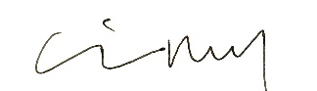_______________________________
Name of signee _Erin McKay_________________________________________________
Position and Agency/Organization _Senior Natural Resource Specialist, Chelan County Natural Resource Department_____________
Date Submitted: _1/12/22____________

Appendix A: Project maps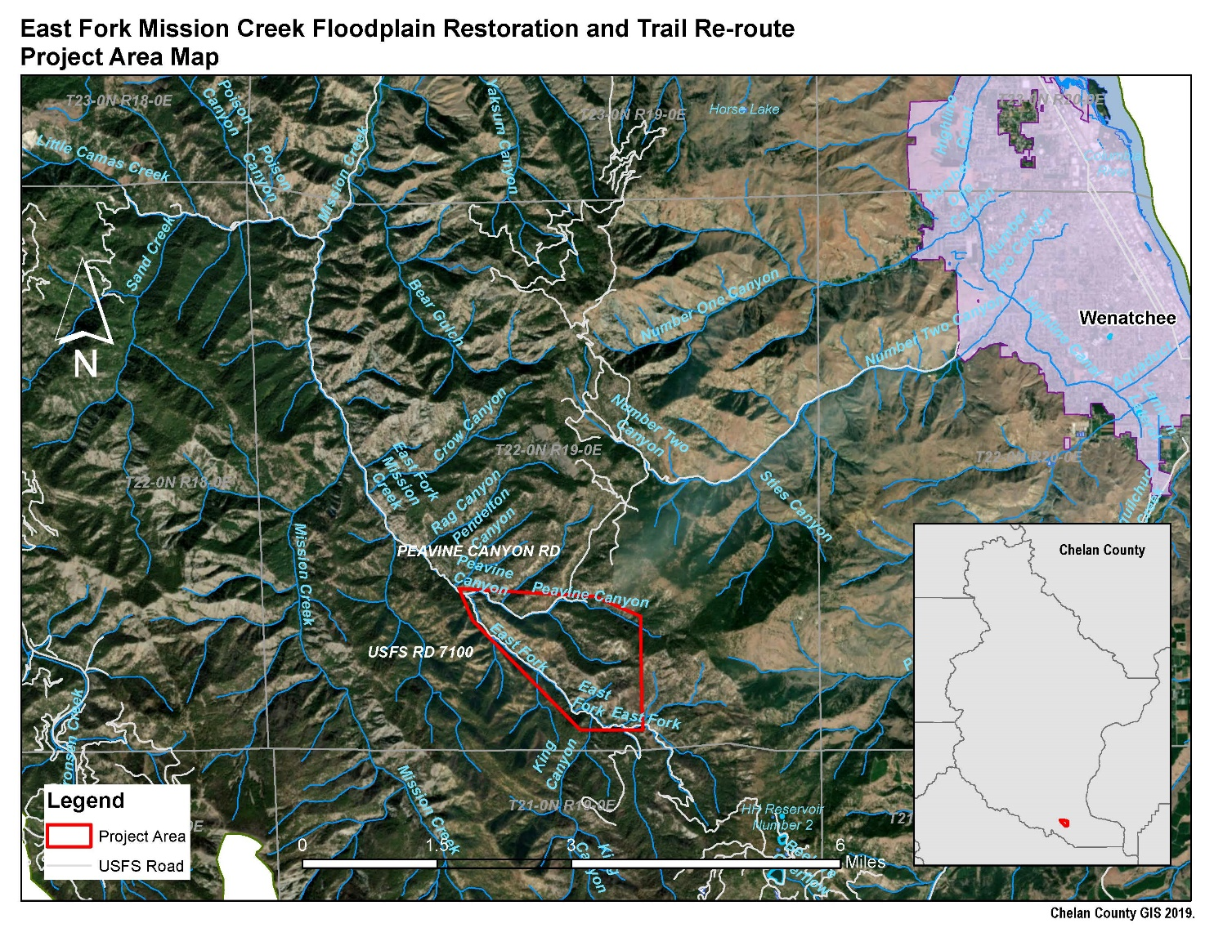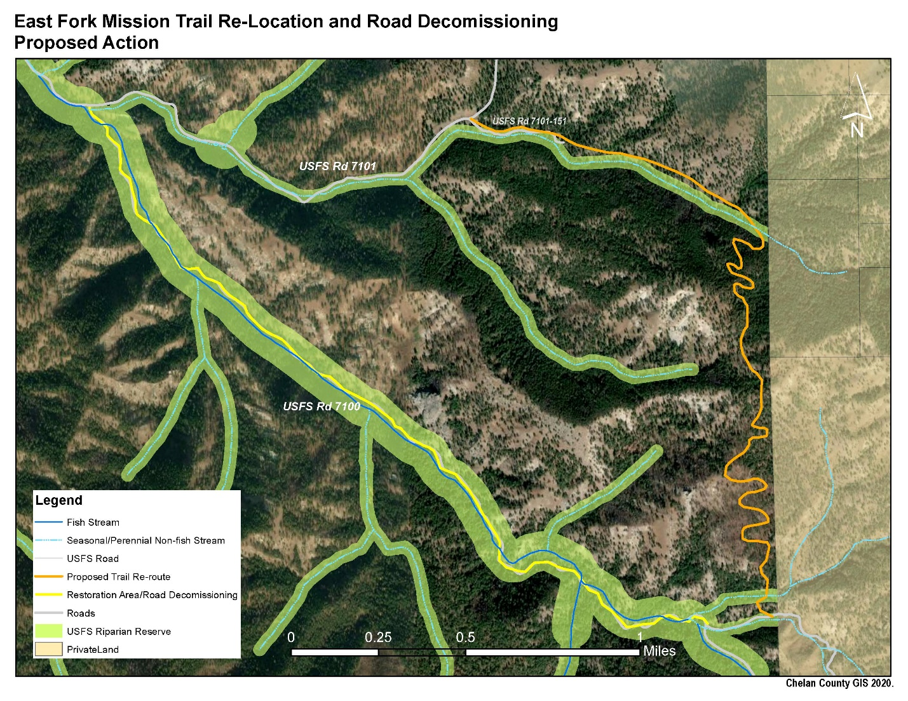

Appendix B: Project plans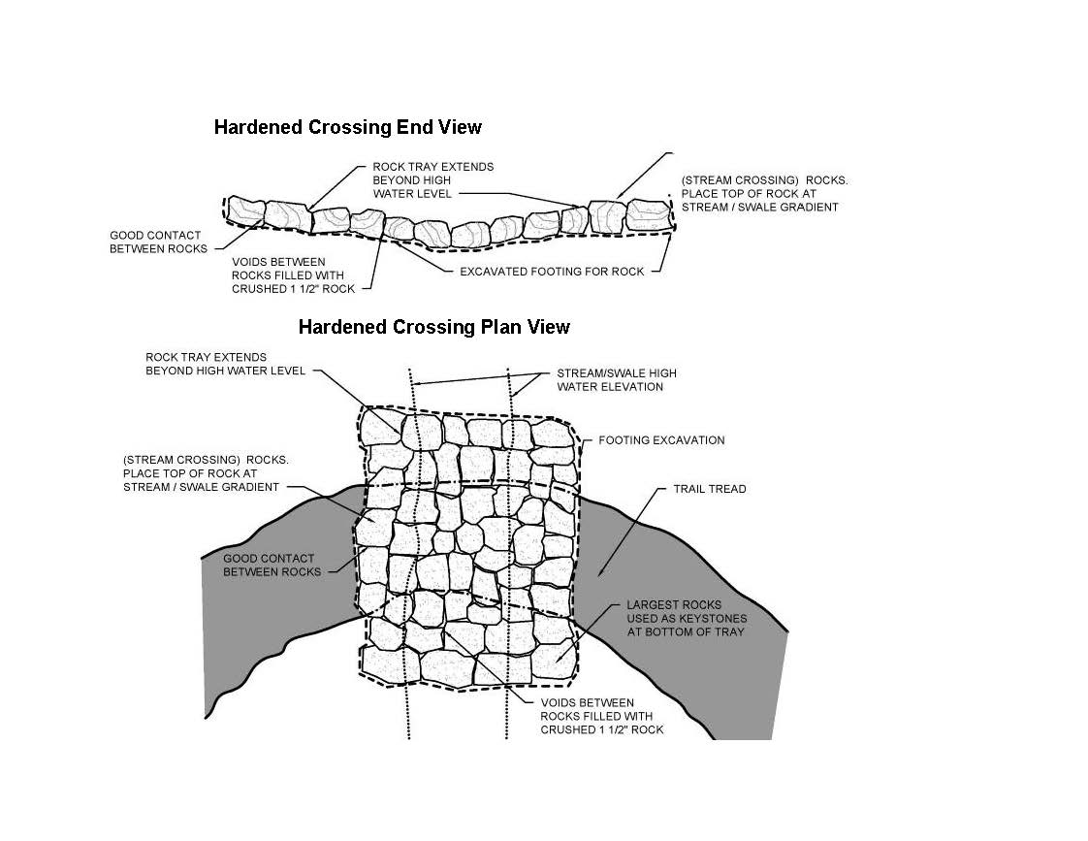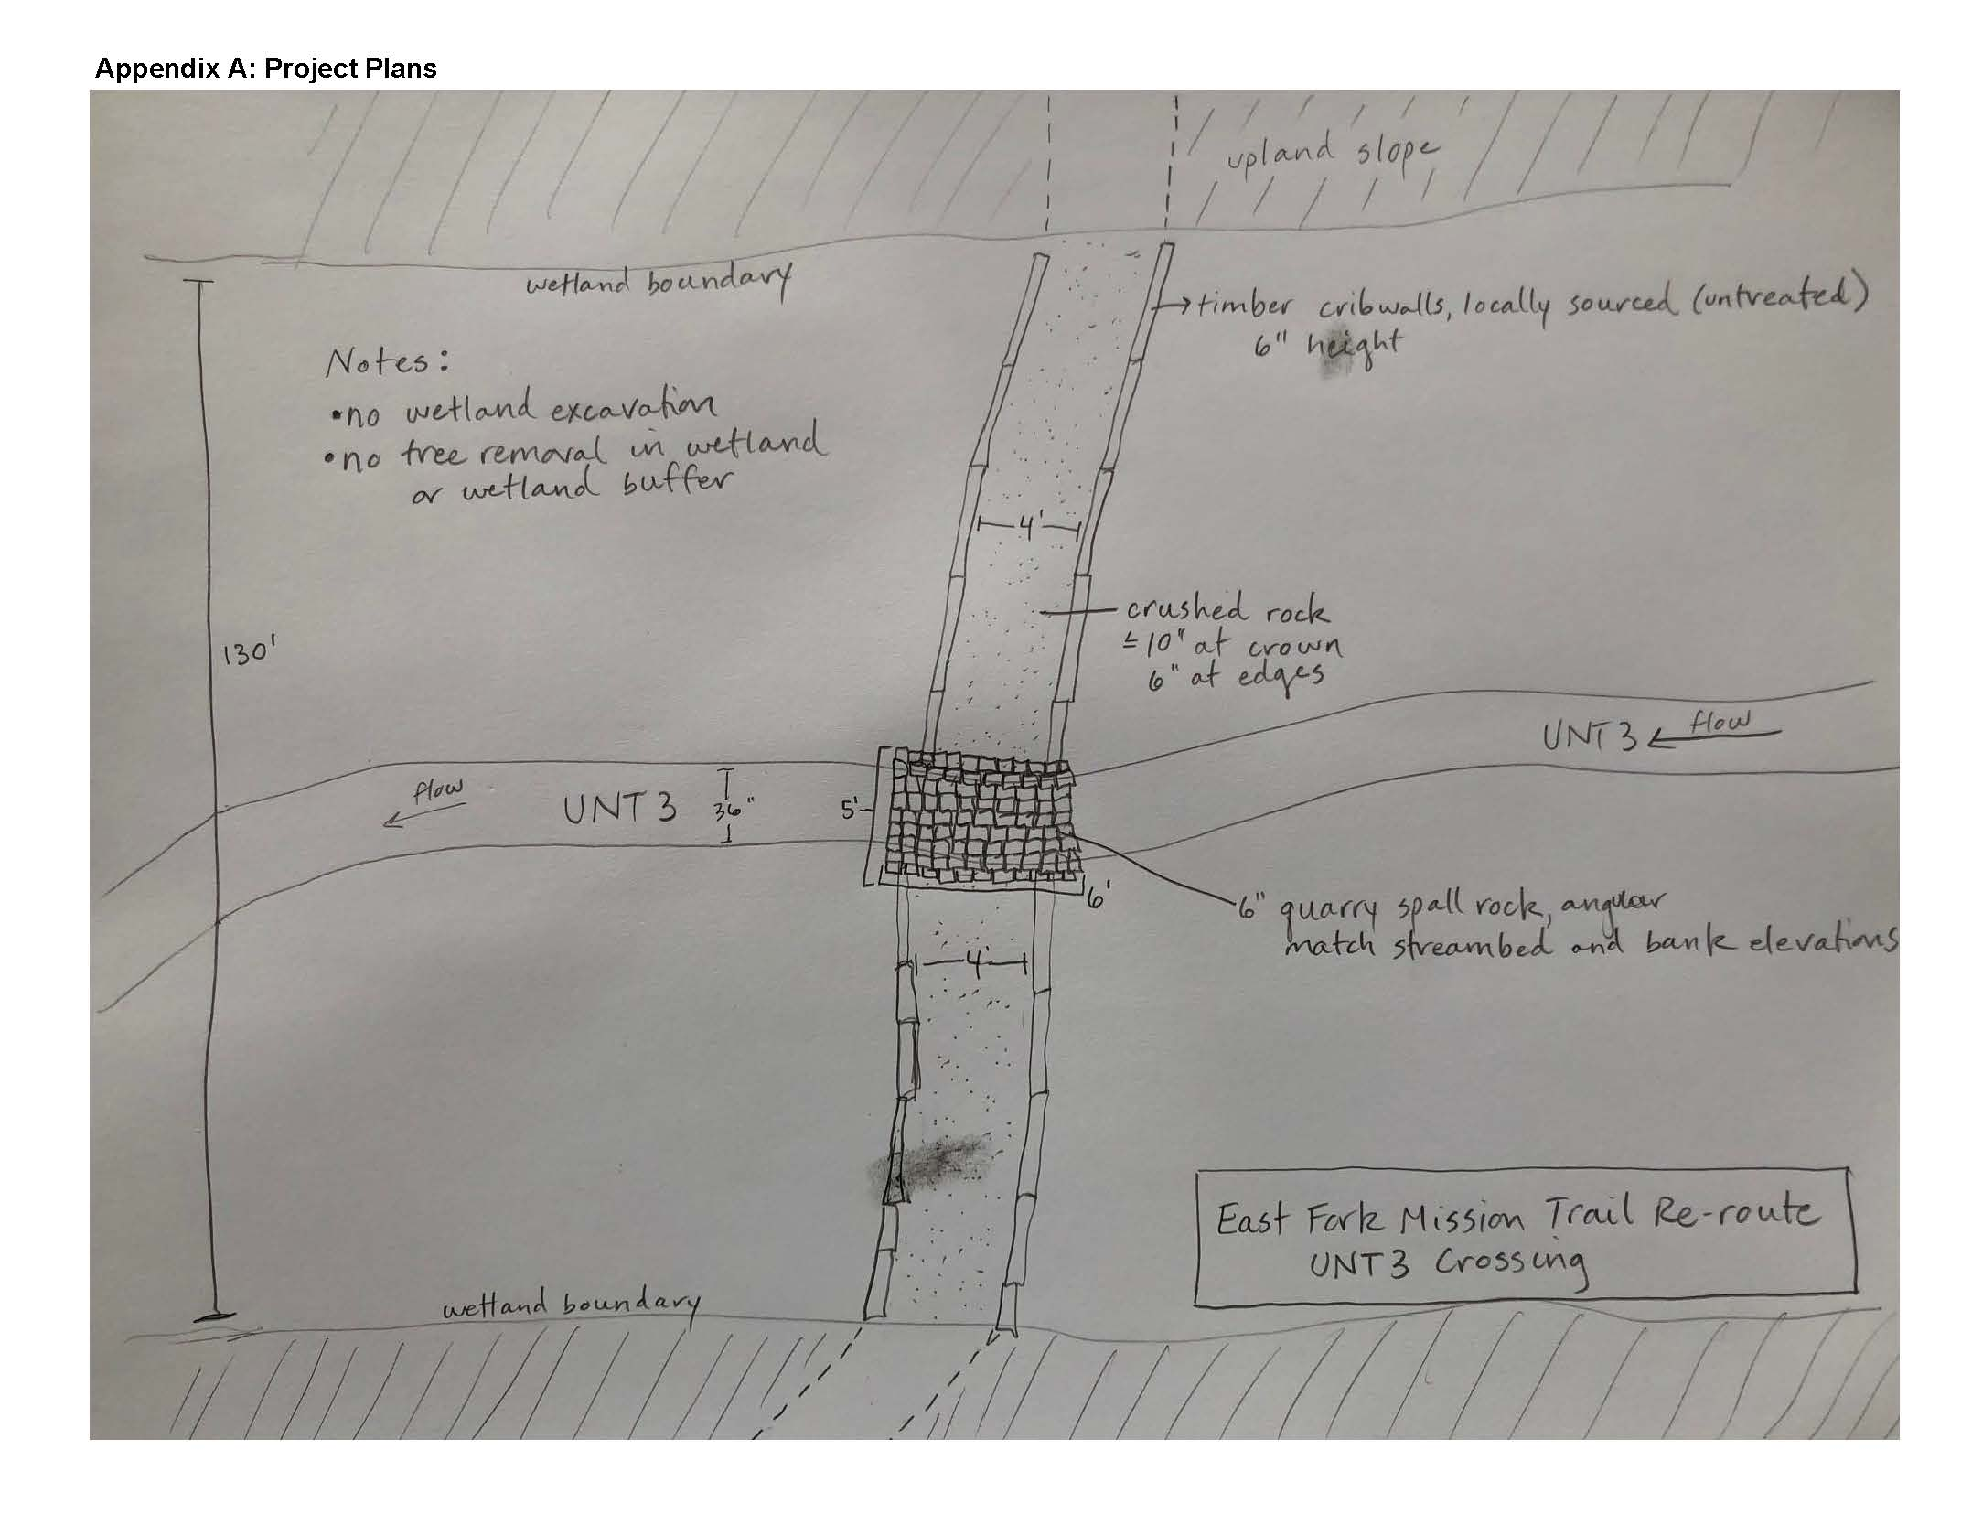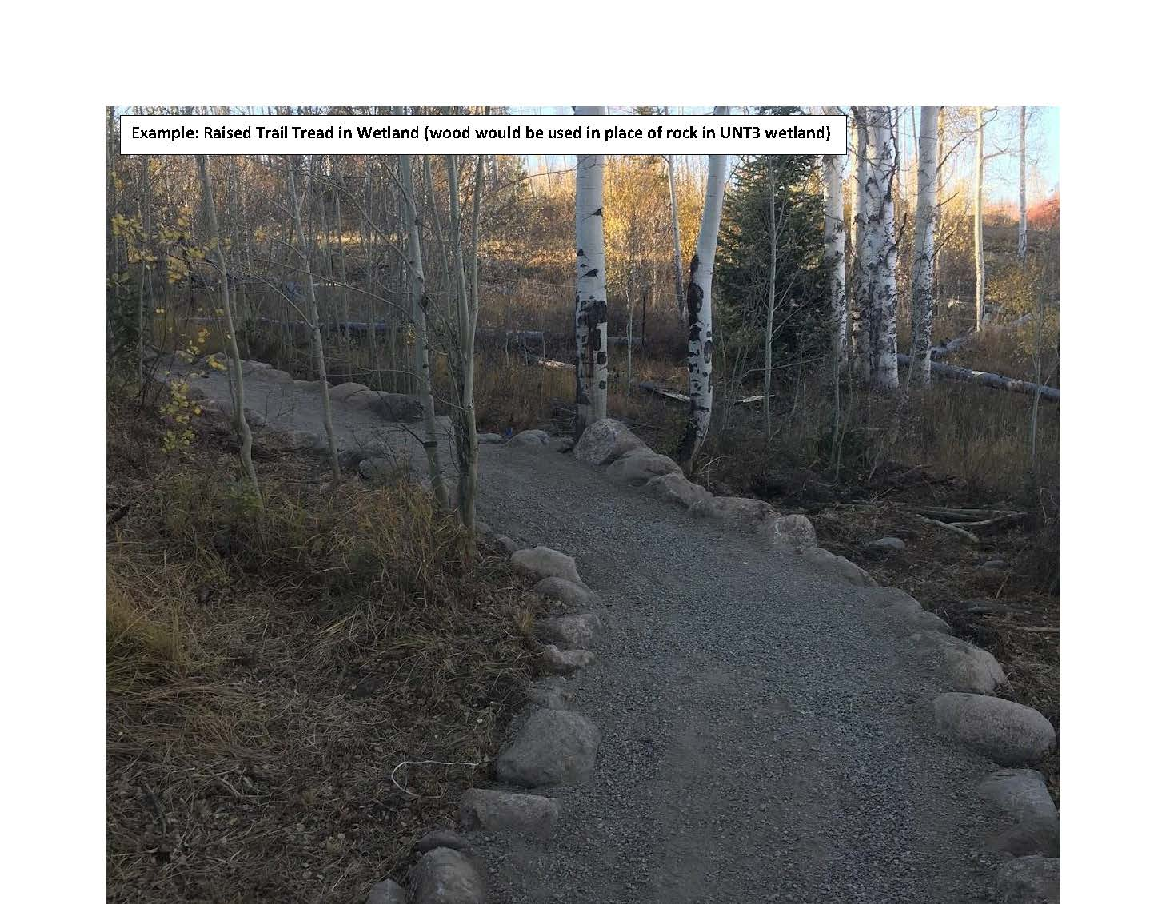

Appendix C: Project photos 