Climate Resiliency Round Table Meeting
November 18, 2021

Introduction
A 90-minute online meeting was led by Lisa Dowling (Chelan County) and Ben Floyd (White Bluffs Consulting), with Lisa Grueter (BERK) and John Todoroff (BERK) supporting the meeting presentation and meeting operation and documentation. About 36 participants joined the meeting.
The presentation covered the Chelan County Climate Resiliency Strategy’s purpose and Round Table organizational structure, and efforts so far. Meeting attendees participated in a group activity to identify desires for participating in the Round Table and joining sub-committees that would develop preliminary priorities for a one- to two-year work plan.

Poll Exercise
Using a series of Zoom poll questions, the group was asked to prioritize actionable strategies. Participants identified the most important and most feasible strategies to undertake, for the following topic areas: Wildfire, Water Resources, Public Health and Safety/Vulnerable Communities, and Outreach and Education. Additionally, they were asked which small committee, focused on each of the previously listed topic areas, they would prefer to participate in. A range of 25 to 27 attendees responded to each of the questions in the poll exercise.
Exhibit 1. Poll Results
Wildfire  What is your top priority for wildfire?  “Proactively address fire resiliency” was the clear leader with 63%, followed by “Develop fire safe places in fire prone areas” at 30%. | 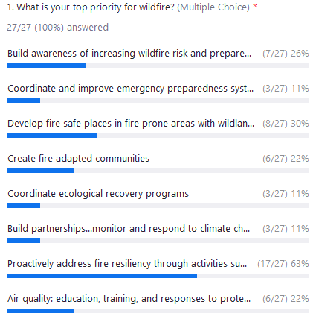
Water Resources  What are your top two priorities for water resources?  “Promote and encourage water efficiency and conservation” led with 40%, followed by “Reduce impacts of climate change to aquatic systems” with 37% and “Evaluate and improve stormwater management and infrastructure” with 30%. | 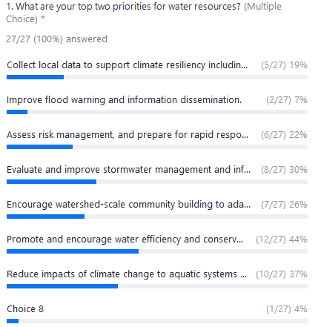
Public Health and Safety/Vulnerable Communities  What is your top priority for public health and safety/vulnerable communities?  68% of participants chose “Build capacity to assist the most vulnerable people to prepare and respond to threats”, followed closely by “Develop priorities and strategies to integrate adaptation measures for vulnerable populations” with 64%. | 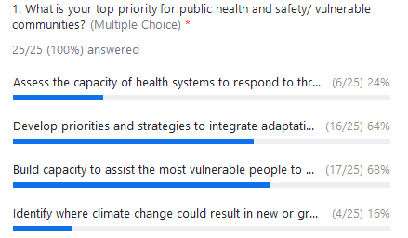
Outreach and Education  What is your top priority for education and outreach?  Participants chose “Connect local communities to resources that increase community emergency preparedness, improved use of energy or natural resources, or resiliency to climate impacts” the most with 62%, followed by “Ensure climate resilience outreach efforts are multi-lingual to engage all members of the community” with 58%. | 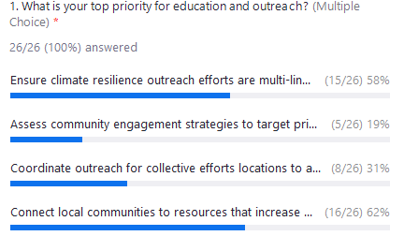
Small Committee  What is your first choice to participate in a small committee?  Wildfire was the top answer with 31%, followed by Water supply and Outreach/communications, each with 27%. | 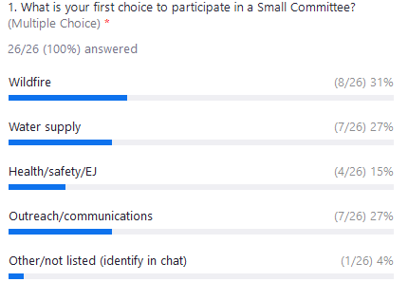

Questions and Answers
After the polling, the group had an open question and answer session.

Group Formation and Resources
Asked about updates, Ben Floyd responded that the project team will be putting out updates and invitations to the group.
A participant asked if core representatives in each small committee have already been identified, and Lisa Dowling responded the project managers have contacted some people to ask them to take on co-lead roles, but those requests are still in progress and will be announced once the charter is finalized. Lisa Dowling would love to hear from anyone interested in participating as a co-lead.
The project team is currently in the process of recruiting people to lead or co-lead the four small committees, but the list of people taking on leadership roles is not publicly available yet. People who have capacity and interest to volunteer, and a job role or expertise that aligns with the work, are encouraged to contact the project team.
Regarding recruitment, the business community is invited to participate in the project, although at this point there is not an intent to involve any specific industry areas.
Crystal Raymond with the UW Climate Impacts Group is hoping to recruit others from state agencies to get involved in the small committees. The UWGIG is hiring two staff to specialize in climate resiliency and vulnerable communities. The Round Table group’s emphasis on vulnerable populations is appreciated and the group should collaborate with organizations representing them.

Funding
Regarding resources and funding, County staff have been investigating sources of funding to support groups, including non-profits, working on the project. When available, details about funding will be posted on the project website and shared in an email blast to subscribers.
The project team is pursuing grants and will probably have details to share about them in early 2022. The state can offer grants as well as other supports. The Climate Resiliency Round Table group can make the case that their work is valuable as a model for rural communities on the east side.

Round Table and Small Group
Some asked about areas of focus for small committees and potential overlap. Climate change-related displacement will be addressed by the Public Health and Safety/Vulnerable Communities topic area small committee. The Wildfire and Water Resources small committees will address terrestrial and aquatic wildlife habitats, respectively. It is expected that each committee’s work will have a degree of overlap with the others.

Round Table Work and Other Initiatives
In response to a concern that this group might be competing with related work that other groups have been doing, Lisa Dowling responded that the intent is to help coordinate and complement the work being done by other groups and to be a resource for them without adding to their workload or competing.
Ben affirmed that the Climate Resiliency Round Table’s work will coordinate with other work such as the Our Valley Our Future visioning process and 5-Year Action Plan.

Strategies
About the status of the strategy, the Draft Climate Resiliency Strategy is being finalized and in the adoption process to be included as a component of Chelan County’s Natural Hazard Mitigation Plan. Work on the Climate Resiliency Strategy has informed policy changes in the Comprehensive Plan.

Meeting Feedback
Feedback and discussion about the polling exercise included:
- There should have been an option for participants to add to the list of actions. Ben responded that the actions were items identified in Draft Strategy and the December 2020 workshop plus snapshots of current activities that are going on. There will be opportunities to suggest adding other actions.
- It was easy and democratic to rank priorities, but required a good base knowledge of the tasks and what they may include.
This was a preliminary exercise to get the group thinking about priorities and there will be opportunities to learn more about the proposed actions and develop a more systematic approach to prioritizing them.

Chat
Comments in the Zoom chat window included:
- The Executive Committee should be responsible for keeping the processes moving forward including making sure deliverables and timelines are met, and the Science Committee should provide data to support subcommittees’ analysis and decision making.
- Participants suggested the four focus areas should be expanded to include climate change-related displacement, and impacts on business and industry.
- Washington State University’s Center for Sustaining Agriculture and Natural Resources is a resource for the project.
- AgClimate.net, a blog produced by Northwest universities including WSU, discusses climate change impacts, practices to address them, and issues related to greenhouse gas emissions. The focus is on climate change and agriculture and natural resources, focused on our region, and relevant to wildfire, water, people, etc.
- Displacement is a major component of each of the topic areas, both currently and increasingly in the future with climate refugees coming from other states.
- The polling exercise is just the beginning of the process of the Round Table group determining actions to advance in the next one to two years.

Next Steps
Lisa Dowling and Ben noted the next steps in the process included:
- Finalize Charter (feedback welcome through 12/31/21)
- Complete 2021 Status Report
- Expand Resource Library (please submit resources to Lisa.Dowling@co.chelan.wa.us)
- Convene Small Committees with brief kick-off meetings for small committees in January 2022
- Establish Round Table Quarterly Meeting Series
- Meeting Series for 2022: February 17, May 19, August 18, and November 17

