Chelan County
Department of Community Development
2022 Comprehensive Plan Amendment
Staff Report

TO: Chelan County Board of Commissioners
FROM: Department of Community Development
HEARING DATE: January 31, 2023
FILE NUMBER: ZTA-22-419 (Proposed 2022 Leavenworth Urban Growth Area Amendments)

  - RECOMMENDED MOTION
The Planning Commission has recommended adoption of this proposal. Adoption of the proposed amendments aligns with countywide planning policies, county planning policies, and the 1997 interlocal planning MOU and RCW 36.70A.100. Land use changes are not in conflict with Chelan County planning policies and proper public notice procedures have been followed. Staff recommends:
- Move to approve the proposed Leavenworth Urban Growth Area Amendments, given file number ZTA-22-419, based upon the findings of fact and conclusions of law contained within this January 31, 2023 report.
GENERAL INFORMATION
Applicant | Chelan County
Planning Commission Workshop | September 27 and 28, 2022
Planning Commission Notice of Hearing | October 12, 2022
Planning Commission Hearing on | October 26, 2022  (Recommendation: Approval, with the exception of removing reference to 18.42.030  in City of Leavenworth Ord #1654)
Board of County Commissioners Workshop | December 20, 2022 and January 24, 2023
BOCC Notice of Hearing Published | January 21, 2023
60-day State agency review | Initiated: October 6, 2022
SEPA Determination | October 12, 2022

SEPA Environmental Review
A Determination of Non-Significance was issued under WAC 197-11-355 for ZTA-22-419 on October 12, 2022 (Attachment 1). The lead agency for this proposal has determined that it does not have a probable significant adverse impact on the environment. An Environmental Impact Statement (EIS) is not required under RCW 43.21C.030(2)(c). The decision was made after a review of a completed environmental checklist and other information on file with the lead agency.

Agency Comments:
None received to date. (If received prior to hearing, will be Attachment 2.)

Public Comment:
None received to date. (If received prior to hearing, will be Attachment 2.)

60-Day Notice:
Sent to Department of Commerce October 6, 2022. Letter of acknowledgement included as attachment 3. Revised notice was mailed to the Department of Commerce.

Introduction & Background
The City of Leavenworth has submitted 14 proposed amendments to its Urban Growth Area (UGA) Development Regulations. These are summarized in the table below. See Attachment 6 for the full text of each amendment, along with SEPA documentation.

Exhibit 1. Land Use Regulation Changes in Leavenworth Urban Growth Area
Ordinance | Description
1542 | Update Bed & Breakfast (short-term rentals) regulations
1543 | Update and clarify Duplex and ADU regulations
1583 | Define zero lot line development and provide standards
1585 | Permit cryptocurrency in the light industrial district
1588 | Update planned development district and define affordable housing
1590 | Regulate and allow mechanical stacked parking
1596 | Amend code regarding:  - Concurrency standards for public facilities and utilities  - Development standards for manufactured homes  - Permitted uses in commercial districts  - Development code administration for Comprehensive Plan amendments and Development Regulation amendment process  - Official zoning map
1627 | Create new district use chart, revise definitions and land use regulations
1628 | Address code consistencies. Amend chapters about code interpretation and variances. Amend Supplementary Regulations regarding:  - Visibility obstructions  - Fences  - Accessory buildings  - ADUs  - Bed and Breakfast facilities  - Duplexes  - Building height limit exceptions  - Home occupations  - Major recreational equipment  - Unlicensed vehicles  - Yard requirements  - Decks, patios, and balconies
1650 | Amend Comprehensive Plan with updated Land Capacity Analysis, and updates Land Use Designations map
1651 | Replace RL10 and RL12 zoning districts with new R-8 district and update District Use chart and official zoning map
1654 | Establish Affordable Housing Incentive Program to encourage development of housing units for households with low and moderate incomes

Chelan County Code Requirements
These regulations are evaluated in accordance with Chelan County Code Section 14.13.040 Development Regulation Amendment evaluation criteria, Chelan County Code Section 14.14.047 Amendment review criteria for comprehensive plan text changes, and Chelan County Code Section 14.14.060 for Comprehensive Plan Maps. These criteria determine the process for approval, modification, or denial of regulation amendment applications and text amendments to county-adopted city comprehensive plans.

(1) The amendment/proposal is necessary to resolve a public land use issue or problem.
Finding: In the 1997 interlocal planning MOU, Chelan County establishes policies with the City of Leavenworth regarding land use regulations within its Urban Growth Area (UGA). Chelan County agrees to adopt the city’s “land use regulations, development standards and land use designations for the city’s UGA.” The County also agrees to implement the city’s “street, street lighting, curb, gutter and sidewalk design standards” within the UGA.
GMA requires comprehensive planning for counties and cities designated under its jurisdiction. RCW 36.70A.100 details that each city’s comprehensive plan must be coordinated and consistent with “other counties or cities with which the county or city has, in part, common border or related regional issues”.
Chelan County has not adopted relevant land use changes and comprehensive plan amendments for the city of Leavenworth’s UGA since 2016. This amendment is necessary to resolve this issue, including amendments from 2016–2022, and bring the County into alignment with the agreement outlined in the MOU and relevant state planning policies.

(2) The amendment is consistent with goals of the Growth Management Act, Chapter 36.70A RCW.
Finding: The GMA planning goals include but are not limited to the following:
- Urban growth. Encourage development in urban areas where adequate public facilities and services exist or can be provided in an efficient manner.
- Reduce sprawl. Reduce the inappropriate conversion of undeveloped land into sprawling, low-density development.
- Housing. Encourage the availability of affordable housing to all economic segments of the population of this state, promote a variety of residential densities and housing types, and encourage preservation of existing housing stock.
- Economic development. Encourage economic development throughout the state that is consistent with adopted comprehensive plans, promote economic opportunity for all citizens of this state, especially for unemployed and for disadvantaged persons, promote the retention and expansion of existing businesses and recruitment of new businesses, recognize regional differences impacting economic development opportunities, and encourage growth in areas experiencing insufficient economic growth, all within the capacities of the state's natural resources, public services, and public facilities.
- Permits. Applications for both state and local government permits should be processed in a timely and fair manner to ensure predictability.
The adoption of the city’s comprehensive plan amendments and land use regulations within the UGA is consistent with the first two GMA goals, to encourage development in urban areas and to reduce sprawl. Housing and subdivision related amendments included for adoption promote the variety of residential densities in housing types within the UGA. Other land use updates encourage economic development consistent with the adopted comprehensive plan. Updating standards within the UGA will also support the timely review and processing of development applications to ensure predictability.

(3) The amendment complies with or supports comprehensive plan goals and policies and/or county-wide planning policies, or how amendment of the comprehensive plans’ goals or policies is supported by changing conditions or state or federal mandates.
Finding: The City of Leavenworth has reviewed and found the proposed amendments consistent with the City’s Comprehensive Plan goals and policies. The County-wide Planning Policies support the use of the City regulations within the UGAs and adoption of city comprehensive plan amendments.

(4) The proposed amendment does not adversely affect lands designated as resource lands of long-term commercial significance or critical areas in ways that cannot be mitigated.
Finding: The proposed amendments do not change resource lands or critical area regulations which would be reviewed based on the site-specific development at the time of future permit.

(5) The amendment is based on sound land use planning practices and would further the general public health, safety and welfare. The comprehensive plan amendment would serve the interests of not only the applicant, but the public as a whole, including health, safety, or welfare.
Finding: The proposed amendments are the result of appropriate planning processes to reflect the community desire for development.

Procedural Requirements
Appropriate City procedures have been followed for each amendment proposed for County adoption including hearing notices, 60-day notices to the State Department of Commerce (several of which were jointly noted for the City and County). The State Environmental Policy Act (SEPA) was addressed based on the determinations of the City’s responsible official. The County has included the amendments in its 2022 Docket with a notice to the Department of Commerce, hearing notice, and review of the City’s SEPA documents and adoption. Additionally, a set of housing-related ordinances incorporated extra public engagement effort. In 2021 and 2022 the City publicized the discussion of housing code amendments (including Ordinances 1640, 1650, 1651, and 1654 regarding R-8 zoning, duplexes, and low-income housing development) by mailing a postcard to local residents with information about the Housing Action Plan and current discussions about housing code amendments, a link to a public-facing page about housing on the City’s website, and an invitation to meet with Development Services staff.

Ordinance Descriptions
Ordinance 1542 amends LMC Chapter 18.52.120 to clarify and update the Bed and Breakfast (short-term / vacation / overnight rentals in residential neighborhoods) regulations, criteria, and standards. It requires bed and breakfast facilities to be the principal residence of the property owner, sets limits on number of occupants, sets sign standards and parking requirements, and establishes an inspection and permitting process.
Note: Per CCC 11.88.290 (C) (iv) The board of Chelan County commissioners adopts the cities of Cashmere, Chelan, Entiat, Leavenworth, and Wenatchee land use regulations, development standards and land use designations, as they apply to short-term or vacation rentals of fewer than thirty consecutive nights or days, within the county adopted unincorporated urban growth area respecting each city as it is now or is hereafter amended for the cities of Cashmere, Chelan, Entiat, Leavenworth, and Wenatchee; provided, that any city regulation requiring acquisition of a business license is not adopted nor incorporated as a county regulation and that instead a conditional use permit may be required, and the county’s review procedures in this section must control.
Ordinance 1543 updates and clarifies ADU and Duplex regulations in LMC 18.20, 18.21, 18.22, and 18.23 (permitted and conditional uses in RL6, RL12, Multifamily Residential, and RL10 districts). It allows ADUs as a permitted use in these districts, and sets requirements including non-transient use, a limit of one ADU per home site, minimum one parking space, and maximum 1,200 square feet. The ordinance requires a minimum lot size of 12,000 square feet for duplexes.
Ordinance 1583 defines zero lot line development in LMC Chapter 21.90, and amends Chapter 18.24.090 to provide standards for yards, setbacks, lot coverage, and design articulation.
Ordinance 1585 defines cryptocurrency mining in LMC Chapter 21.90.030, and amends Chapter 18.45.20 to permit cryptocurrency mining facilities in the light industrial district and requires verification of meeting Chelan County PUD requirements, electrical consumption impacts, and a permit from Washington State Department of Labor and Industries.
Ordinance 1588 updates Chapter 18.40 to set requirements for residential or multiple-use Planned Development as a conditional use, including public benefit, perimeter transitions, minimum site size and scope, road improvements, density, setbacks, height limits, maximum site coverage, parking, recreation areas, and other characteristics.
Ordinance 1590 defines stacked parking in Chapter 21.90.030 and sets design requirements. It permits stacked parking in General Commercial, Central Commercial, Tourist Commercial, Residential Low Density RL6, RL10, and RL12, and Multifamily Residential districts.
Ordinance 1596 amends the code in the following areas:
- Chapter 14.14 and 17.020.070 — Concurrency for public facilities and utilities
- 14.16.080 — Manufactured home standards
- 18.28.020, 18.32.020, and 18.44.020 — Permitted and conditional uses in the General Commercial, Central Commercial, and Tourist Commercial districts.
- Development code administration:
  - 21.31.030 — General time frame for Comprehensive Plan amendments
  - 21.35.010 — Initiation of development regulation and zoning map amendments
  - 21.03.030 — City Council review of recommendations of the Planning Commission
  - 18.12.010 — Official zoning map amendments
  - 18.12.040 — Penalty for unauthorized change of the official zoning map
  - 18.12.050 — Official zoning map shall be maintained at City Hall
Ordinance 1610 amends the code regarding subdivisions in the following areas:
- Chapter 17.080.010 and 17.08.070, regulating Short Plats, divisions of land into nine or fewer plots
- 17.12.010 — Chapter applies to Major Subdivisions of land into ten or more plots
- 21.90.030 — Amending definitions of final short plat, final plat, major subdivision, and short subdivision
Ordinance 1627 creates a new district use chart, and revises definitions and land use regulations.
Ordinance 1628 addresses code consistencies, amends Chapter 18.04.030 regarding code interpretation and variances, and amends Supplementary Regulations regarding:
- 18.35.005 — Purpose and Applicability of supplementary regulations
- 18.35.010 — Visibility obstructions
- 18.35.020 — Fences, walls, and hedges
- 18.35.030 — Accessory buildings
- 18.35.035 — Accessory Dwelling Units
- 18.35.038 — Bed and Breakfast facilities
- 18.35.040 — Prohibiting more than one principal structure in low-density residential districts
- 18.35.045 — Duplex dwellings
- 18.35.050 — Exceptions to building height limits
- 18.35.060 — Home occupations
- 18.35.070 — Major recreational equipment
- 18.35.080 — Unlicensed vehicles: parking and storage restrictions
- 18.35.090 — Yard modification requirements
- 18.35.100 — Decks, patios, and balconies
Ordinance 1640 removes minimum lot size requirement for duplexes, making it the same as for single family dwellings, in RL6, RL12, and RL10 districts. It amends Chapter 21.90 definitions for duplex and removes duplexes as a conditional use in Chapter 18.52.130.
Ordinance 1650 amends the Comprehensive Plan with an updated Land Capacity Analysis and an updated 2021 Land Use Designations map that includes a new R8 zone. The related Ordinance1651 amends the zoning code and adopts the new official zoning map. Maps in Figure 1 and Figure 2 below show where RL10 and RL12 zones are changed to the new R8 zone.
Ordinance 1651 amends Chapter 18.21 to replace RL10 and RL12 zoning districts with a new R8 district and updates the District Use chart and official zoning map to reflect this change. The R8 district permits single family residences, duplexes, and accessory dwelling units, with a minimum lot size of 8,000 square feet. Areas where RL10 and RL12 zones are changed to R8 are shown in the yellow areas on the map in Figure 1and dashed yellow outlines on the map in Figure 2 below.
Figure 1. Leavenworth Comprehensive Plan Land Use Designations
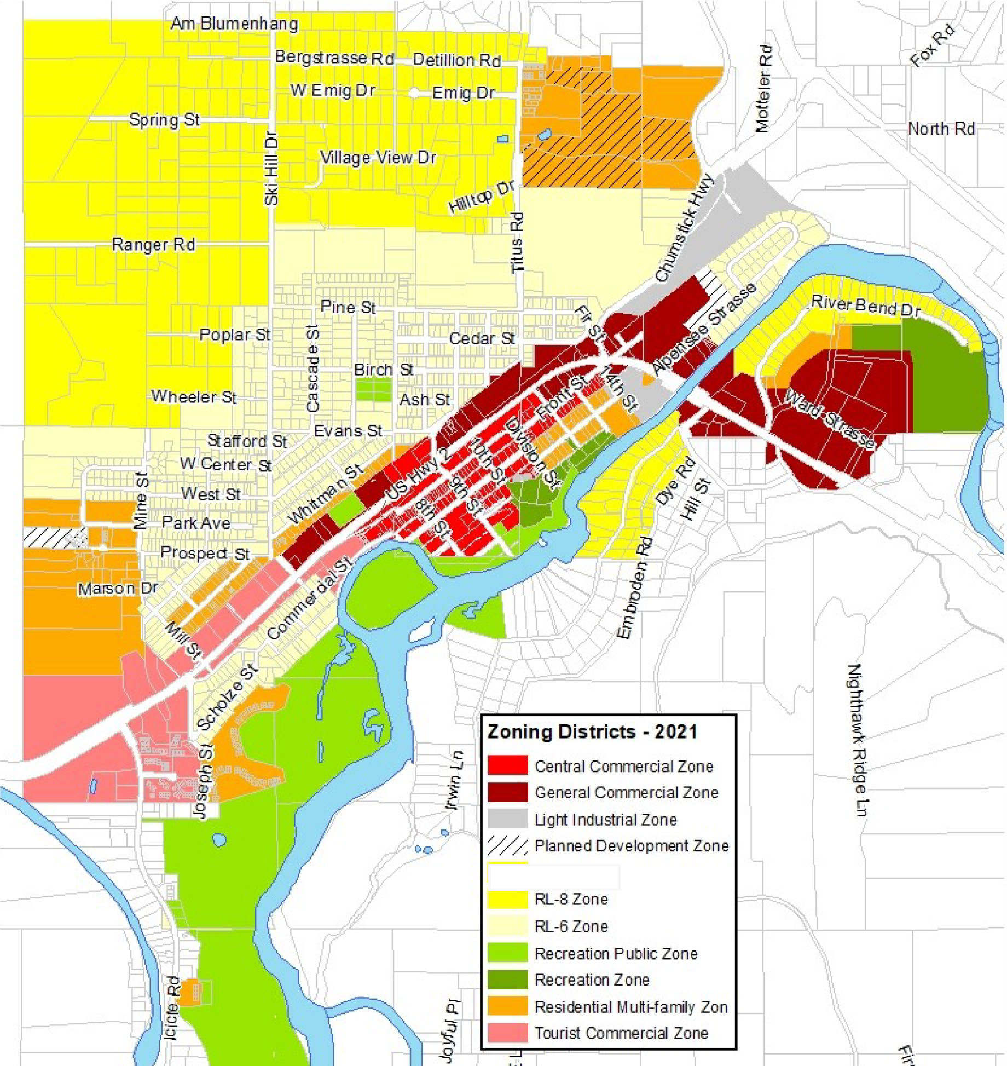

Figure 2. Chelan County zoning map of area surrounding Leavenworth

Ordinance 1654 amends Chapter 18.42 to establish the Affordable Housing Incentive Program, with the intent to encourage development of housing units that are affordable to service industry workers and others with low or moderate incomes. To incentivize development, regulations are modified pertaining to density, lot coverage, front yard setbacks, alley access, parking, and design standards.

Staff Conclusions
Adoption of the proposed amendments aligns with county planning policies, per the 1997 interlocal planning MOU and RCW 36.70A.100. Land use changes are not in conflict with Chelan County planning policies and proper public notice procedures have been followed. Please refer to Attachment 6 for the full text of each amendment, along with SEPA documentation. Suggested findings of fact and conclusions of law are included below.

Suggested Findings of Fact
- Chelan County and the City of Leavenworth have adopted Comprehensive Plans per the requirements of RCW 36.70A.040 (4) (d), the Growth Management Act.
- RCW 36.70A.210 requires that the Comprehensive Plan be consistent with the provisions of the adopted County-Wide Planning Policies.
- Chelan County has made a determination of non-significance issued on October 12, 2022. The DNS relates to all amendments included for adoption.
- The City of Leavenworth sent notices to Department of Commerce for a 60-day review prior to City Council adoption. The County also sent a notice to the Department of Commerce for a 60-day review prior to Board of County Commissioners adoption.
- Reviewing agencies and the general public were given an opportunity to comment on the proposed amendments.
- Chelan County Code, Title 14, provides review criteria for the consideration of adopting amendments to Comprehensive Plans, Maps, and Development Regulations. Chelan County followed the procedures required for amendments.
- A workshop was held with the Chelan County Planning Commission on September 28, 2022 to review and discuss related amendments.
- A Public Hearing was held with the Chelan County Planning Commission on October 26, 2022. The Planning Commission recommended approval of this proposal (with the exception of removing reference to 18.42.030 in City of Leavenworth Ordinance #1654).

Suggested Conclusions of Law
- The proposed amendments to the City of Leavenworth UGA zoning code and development regulations address a public need or a land use issue.
- The proposed amendments are consistent with the City of Leavenworth Urban Area Comprehensive Plan and the County-wide Planning Policies.
- The proposed amendments are consistent with the goals of the Growth Management Act, Chapter 26.70A RCW.
- The requirements of RCW 43.21C, the State Environmental Policy Act, and WAC 197-11 have been satisfied.
- The proposed amendments do not adversely affect lands designated as resource lands of long-term commercial significance or critical areas in ways that cannot be mitigated.
- The required State agency review with the Department of Commerce (COM) and other State agencies was completed through the review of Leavenworth’s adoption process. The County also sent a notice to the Department of Commerce for a 60-day review prior to Board of County Commissioner adoption.
- Public notice was provided pursuant to Chelan County Code Title 14.
- The adoption of these amendments is in the best interest of the public and furthers the health, safety, and welfare of the citizens of Chelan County.

Recommendation
The Chelan County Planning Commission recommended approval of these Amendments (with the exception of removing reference to 18.42.030 in City of Leavenworth Ordinance #1654) on October 26, 2022. Adoption of the proposed amendments aligns with countywide planning policies, county planning policies, and the 1997 interlocal planning MOU and RCW 36.70A.100. Land use changes are not in conflict with Chelan County planning policies and proper public notice procedures have been followed. Please refer to Attachment 6 for the full text of each amendment, along with SEPA documentation. Suggested findings of fact and conclusions of law are included above in sections F and G.
The Chelan County Board of County Commissioners may make a motion to approve or deny the proposed Comprehensive Plan Amendments, pursuant to Chelan County Code Section 14.10.050. Staff recommends:

Move to approve the proposed Leavenworth Urban Growth Area Amendments, given file number ZTA-22-419, based upon the findings of fact and conclusions of law contained within this January 31, 2023 report.

Attachments
- SEPA Determination, signed October 12, 2022
- Agency and Public Comments (none at time of staff report issuance)
- 60-day Review Acknowledgment Letter from WA Dept. of Commerce
- File of Record
- Planning Commission Recommendation
- Full text and SEPA documentation for Leavenworth Ordinances

