ORDINANCE NO. 1651
AN ORDINANCE OF THE CITY OF LEAVENWORTH, WASHINGTON AMENDING 18.12.010 ADOPTED DISTRICTS ESTABLISHED OFFICIAL ZONING MAP THAT SHALL BE 0N FILE IN ACCORDANCE WITH 18.12.050, RETITLING CHAPTER 18.21 FROM RESIDENTIAL LOW DENSITY 12,000 DISTRICT (RL-12) TO RESIDENTIAL 8 (R-8), AMENDING SECTIONS 18.21.010, 18.21.060,
18.21.070, AND CONSISTENT WITH THAT :RETITLING, REPEALING CHAPTER 18.23, AND AMENDING LMC 18.25.030 DISTRICT USE CHART BY ADOPTING A NEW USE CHART.
WHEREAS, the City Council of the City of Leavenworth directed the Planning Commission through the 2021 Amendment Docket to consider the Housing Action Plan recommendations, including "evaluate converting RL-12 [Residential Low Density 12,000 District] zone into RL*IO [Residential Low Density 10,000 District] zone to reduce incentives for urban sprawl"; and,
WHEREAS, the Planning Commission found that the RL-12 designation was associated with areas impacted by critical areas and/or existing development and converting this land to RL10 would have a small impact; therefore, converting both RL-12 and RL-IO to a new R-8
[Residential 8] could better achieve the identified benefits; and,
WHEREAS, the staff recommended other amendments to the zoning map to correct split zoning and to provide for new Public Recreation for a portion of the Osborn former school; and,
WHEREAS, on October 15, 2021, the City of Leavenworth submitted the amendments to State agencies for review pursuant to RCW 36.70A.106, material ID # 2021-S-3279, with the comment period ending December 14, 2021 ; and,
WHEREAS, on October 20 and 27, 2021, a "Notice of Public Hearing" with the Planning Commission for the amendments was published in the Leavenworth Echo and posted in three locations in City Hall; and,
WHEREAS, the proposed amendments are SEPA exempt, pursuant to WAC 197-11* 800(19); and,
WHEREAS, the City of Leavenworth has followed the requirements of the Leavenworth Municipal Code as it relates to processing of legislative actions; and
WHEREAS, on November 3, 2021, the Planning Commission held a duly advertised public hearing to consider the proposals, receive public comment and make a recommendation to the City Council; and,
WHEREAS, the Planning Commission, after considering public comment, recommended approval of the proposed amendments based on the staff report's finding of facts and conclusions of law; and,
WHEREAS, on October 26, 2021, 2021, the City Council set a public hearing to consider
the amendments; and,
WHEREAS, on December 14, 2021, the City Council held a public hearing to receive and consider public testimony on the amendments; and,
WHEREAS, on December 14, 2021, the City Council remanded the proposed Residential 8 designation and zoning code items back to the Planning Commission for more public engagement and consideration; and,
WHEREAS, the remanded item was reviewed at the January 5, 2022 Planning
Commission regular meeting, at a special staff lead Public Workshop on January 19, 2022, at the February 2, 2022 Planning Commission regular meeting, at a special staff lead Public Workshop on February 16, 2022 and the March 2, 2022 Planning Commission regular meeting; and
WHEREAS, a supplemental staff report was provided to the Planning Commission reflecting additional processes and findings; and,
WHEREAS, on March 2, 2022, the Planning Commission recommended approval of the Residential 8 designation and corresponding zoning map and code amendments; and,
WHEREAS, the City Council makes the following findings:
l . The requirements of RCW 43.21 C, the State Environmental Policy Act, and WAC 197-11 have been satisfied.
- The requirements of the Leavenworth Municipal Code related to the updates and amendments have been satisfied.
- The Planning Commission recommendation was based on the Staff Report findings of fact and conclusion of law.
- The amendments are consistent with the purpose and intent of the City's Comprehensive Plan.
- All public notice and public participation requirements have been met.
- The amendments have undergone sufficient research and evaluation to determine that they may accomplish the purposes for which they are enacted and are intended to further the public health, safety, and welfare.
- The amendments are in the best interest of the public and further the health, safety, and welfare of the citizens of the City of Leavenworth.
- The City Council decision is final unless appealed as provided in Chapter 21.11 LMC, Appeals. The appeal shall meet the requirements of the Growth Management Hearing Board process and procedures.
- The complete case file, including findings, conclusions and conditions of approval, if any, is available for inspection at City Hall during normal business hours, 700 US Hwy 2, Leavenworth, WA. Contact the Development Services Manager, (509) 548-5275.
NOW, THEREFORE, THE CITY COUNCIL OF THE CITY OF LEAVENWORTH, WASHINGTON, DO ORDAIN AS FOLLOWS:
Section 1. Retitled Chapter and amendments. Chapter 18.21 LMC currently titled "Residential Low Density 12,000 District RL-12,000" is retitled "Residential 8000 (R-8)" and Sections 18.21.010, 18.21.040, 18.21.060, 18.21.070, 18.21.080 and 18.21.090 are amended consistent with said retitling all as set out in Attachment A.
Section 2. Repeal. Those chapters and or sections of Title 18 set out in Attachment B, and in particular those in Chapter 18.23 LMC and bearing strike through are hereby repealed.
Section 3. District Use Chart. A new District Use Chan is hereby adopted and Section
18.25.030 is hereby amended to reflect that new District Use Chart as set out in Attachment C.
Section 4. Official Zoning Map. A new official zoning map of the City of Leavenworth is hereby adopted in accordance with LMC 18.12.010 and filed under 18.12.050 as set out in and depicted in Attachment D.
Section 5. This ordinance shall be in effect five (5) days after its passage and publication in accordance with law.
Section 6. If any section or part of this Ordinance, or any attachment is declared unlawful, the balance of the attachment, chapter or section of the Ordinance or of the Attachment shall be unaffected and shall remain in full force and effect.
Passed by the City Council of the City of Leavenworth and approved by the Mayor this 22nd day

of March, 2022.
APPROVED AS TO FORM:
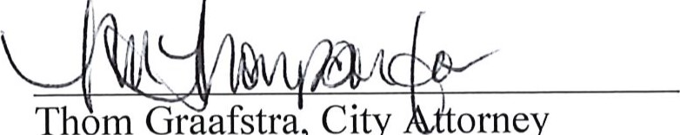
Graafstra,
City
orney
Thom
CITY OF LEAVENWORTH
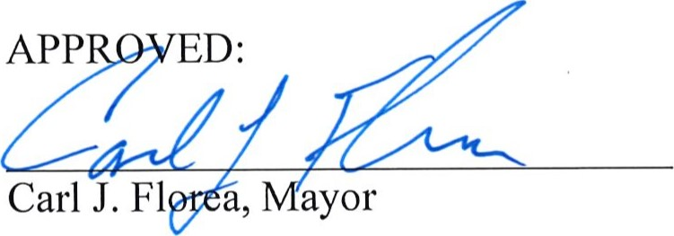
ATTEST:
Clau e.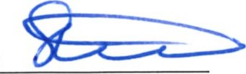
Chantell R. Steiner, Finance Director/City Clerk

ATTACHMENT A
Chapter 18.21 RESIDENTIAL
18.21.010 Purpose.
This is a Fes#ieted-residential district e$-lew-deæi+in which the principal use of land is for singlefamily dwellings, duplexes, and accessory dwellings, together with recreational, religious, and educational facilities required to serve the community. The regulations for this district are designed and intended to establish, maintain and protect the essential characteristics of the district, to develop a nd sustain a suitable environment for
*a-mikesresidents and to prohibit almost all activities of a commercial nature and those which would tend to be inharmonious with or injurious to the preservation of a residential environment.
18.21.040 Yard requirements — Specifications. Unless city code provides for a deviation:
- Front Yard. There shall be a front yard of not less than 25 feet.
- Side Yard. There shall be side yards of not less than 10 feet.
- Rear Yard. There shall be a rear yard of not less than 15 feet for lots without an alley adjacent to the rear yard, and a rear yard of not less than eight feet for lots with an alley adjacent to the rear yard.
- For corner lots, the street side yard shall be a minimum of 15 feet, and at least one rear yard setback shall be provided. For the purposes of this title, street side yard shall be that yard area which is adjacent to a public street right-of-way, but which does not provide the primary access to the residential structure, and/or which does not serve as the street address for the residence.
18.21.060 Lot size.
In a RL4a-dis&FietR-8 district the lot size shall be as follows:
- The minimum area Shall be square
- The minimum lot width at the front building line for new land divisions shall be
18.21.070 Building height. In a R-L12-R-8 district, no structure shall exceed a height of 35 feet.
18.21.080 Lot coverage. In a R•L4-2-R-8 district, buildings and structures shall not occupy more than 35 percent of the lot area.
18.21.090 Off-street parking. Off-street parking shall be provided as required in Chapter 14.12 LMC.

ATTACHMENT B (Repeal)
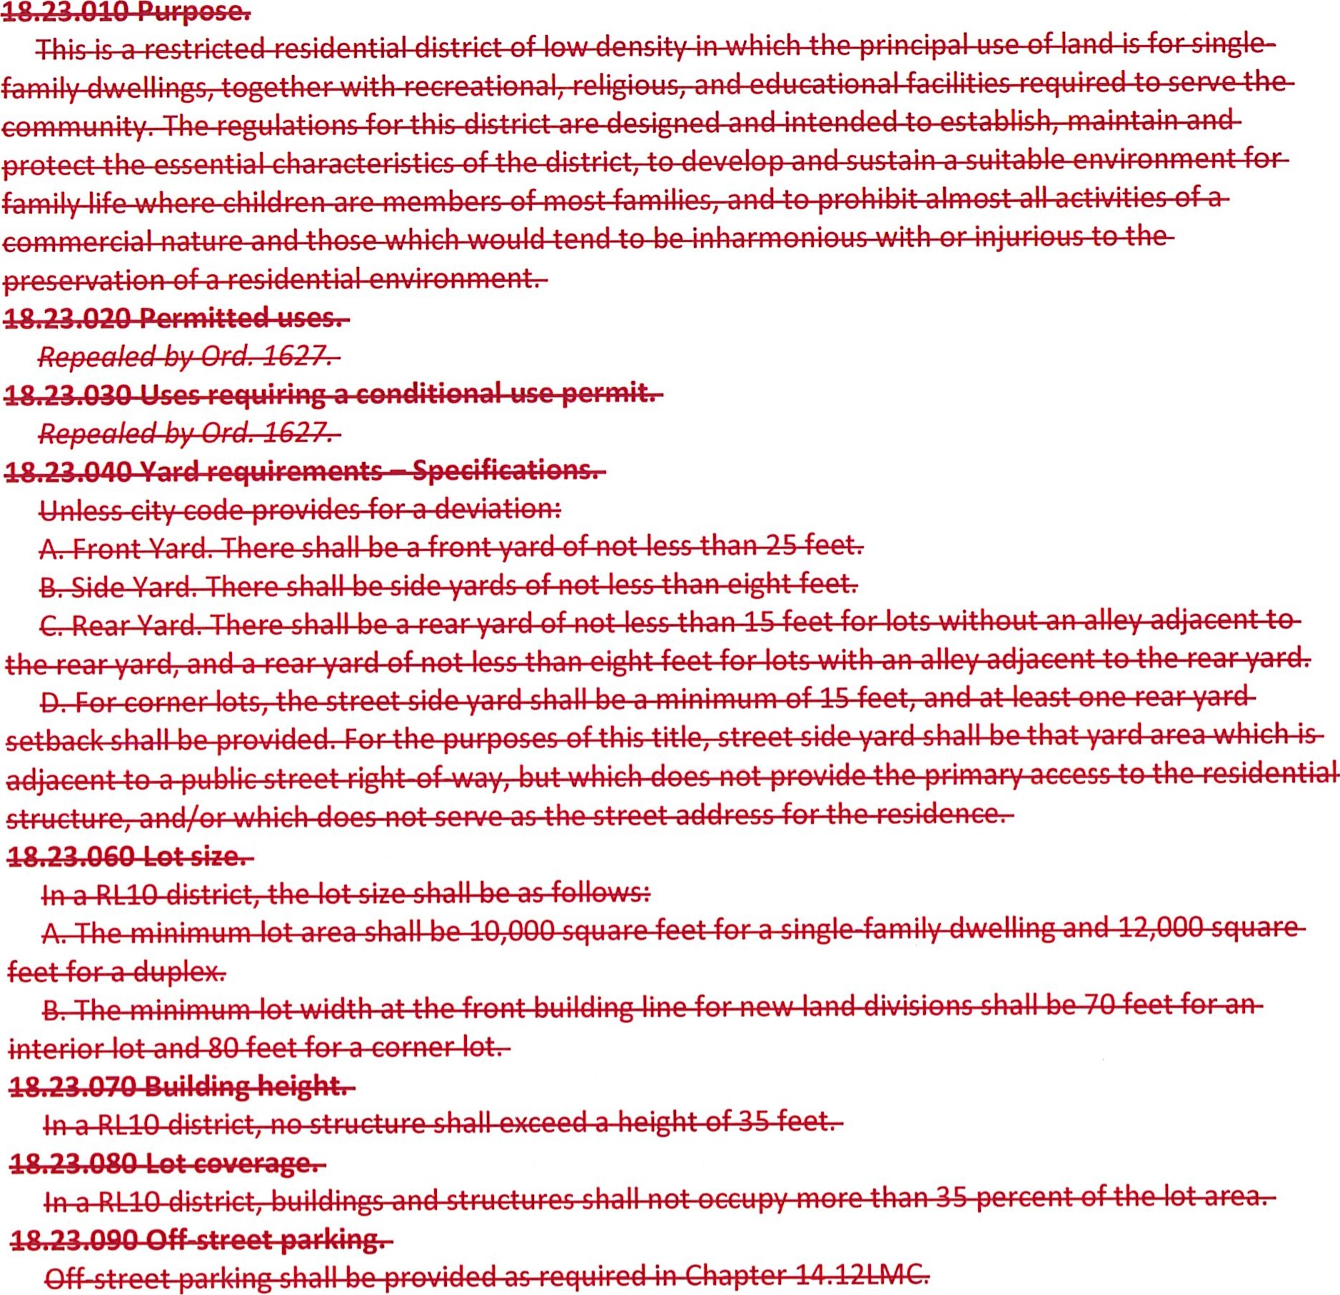
Attachment C District Use Chart
Land Uses | RL6 |  | PtJ4-2 |  |  | CDMUI | GC | cc | TC |  | REC
Residential (Specified Use Below)
Accessory Dwelling Unit | AU
Boardinghouse, Lodging
House, Rooming House
Dwelling, Above Ground Floor
Dwelling, Duplex
Dwelling, Multifamily
Dwelling, Single-Family
Dwelling, Tiny Home
Manufactured Home, Designated
Manufactured Home/Mobile
Home
Vacation (Short-Term) Rental
Accessory Structures and
Uses
Accessory Structure
Adult Family Home
Bed and Breakfast
Child Day Care |  |  |  | AU
Day Care Center
Foster Home
Group A Home Occupation
Group B Home Occupation

Land Uses | RL6 |  |  |  |  | CDMUI | GC | cc | TC |  | REC | RP
Nursing/Convalescent Home, Congregate Care Facility
Stacked Parking
Swimming Pools
Youth Home
Public/Semi-Public (Specified Use Below)
Bus or Taxicab Stop
Clinic
Community Center
Educational Centers
Educational Facilities
Golf Courses
Hospital
Place of Worship
Preschool
Public Facility, High Impact
Public Facility, Low Impact
Public Utility
Recreation, Outdoor Use
Recreation, Passive
Recycling Center
Wireless Telecommunications
Facility
Development Options
Commercial District Mixed Use Incentives

Land Uses | RL6 | 8 | RE-1-2 |  |  | CDMUI | GC | cc | TC |  | REC
Condominiums (with Binding Site Plan) |  |  |  |  |  | p | p | p | p
Incubator Planned Site Development
Manufactured Home Park | c | c
Temporary Subdivision Tract  Offices | c | c
Tiny Home Park | c | c
Commercial/Retail
Adult Entertainment Facilities
Bakery |  |  |  |  |  |  |  | p
 |  |  | *iiiiiiiiiii
Car Wash
Club, Lodge or Fraternal Organization |  |  |  | c |  |  | p
Coffee Roasting
Commercial Amusement
Enterprise, High Impact
Commercial Amusement Enterprise, Low Impact |  |  |  |  |  |  | c | c | c
Copy/Printing Establishment |  |  |  |  |  | c | p | p
Eating and Drinking  Establishment |  |  |  |  |  | p | p | p
Exercise Facilities
Family Entertainment Enterprise |  |  |  |  |  |  | p | p | p

Land Uses | RL6 | 8 |  |  |  | CDMUI | GC | cc | TC |  | REC
Food/Grocery Store
Gasoline Service Station |  |  |  |  |  |  | c |  | c | c
Hostels |  |  |  |  |  |  | p | p | p
Hotel or Motels |  |  |  |  |  |  | p | p | p
Indoor Events/Auditoriums
Laundry or Dry-Cleaning  Establishment |  |  |  |  |  | p | p | p | p
Micro Brewery, Distillery or Winery |  |  |  |  |  | c | c | c | c
Brewery
Mobile Food Vendor
Parking Structure/Lots
Personal Service |  |  |  |  |  | p | p | p
Pet Care Centers/Kennels
Professional Offices (Business and Professional) |  |  |  |  |  | p | p | p
Recreational Vehicle Parks/Campground |  |  |  |  |  |  | c |  | c |  | c
Retail Stores and Services |  |  |  |  |  | p | p
Vehicle Repair Services
Vehicle Sales or Rental |  |  |  |  |  |  |  |  | p | p
Veterinarian/Animal Hospital |  |  |  |  |  | c
Industrial (Specified Use Below)
Bulk Fuel Storage |  |  |  |  |  |  |  |  |  | c
Construction Yards
Cryptocurrency Mining
Land Uses | RL6 | 8 |  |  |  | CDMUI | GC | cc | TC |  | REC
Essential Public Facilities
Feed Lots, Livestock,
Rendering or Meat Packing
Plants
Hazardous Waste Facilities
Heliports and Aviation  Activities |  |  |  |  |  |  |  |  |  | c
Landfills
Light Industry
Storage Facilities, Including Mini- and Self-Storage
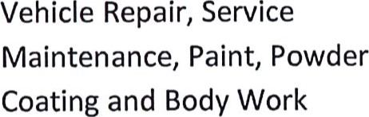
Vehicle Towing, Including
Secured Storage of Vehicles
Warehousing Establishments
Attachment D Official Zoning Map
