Current Conditions, Stemilt-Squilchuck Recreation Planning Area Description (Updated February 2017)

The Stemilt-Squilchuck watershed is situated to the south of Wenatchee and to the north of Ellensburg in Central Washington, and drains north into the Columbia River. The upper watershed is primarily publicly owned and undeveloped, and through conservation efforts by Chelan County, Trust for Public Land, and the Stemilt Partnership, has gained recognition as the Stemilt Community Forest. The majority of the public lands comprising the area of the proposed recreation plan range from 3,000-6,000 feet above sea level and experience four distinct seasons. The lower reaches of the watershed are primarily privately owned and a mixture of dispersed residential and orchard land, and are not included in the recreation planning area. The planning area is bordered by the Stemilt watershed boundary to the south and east, by Mission Ridge Ski Area and Squilchuck Road to the west, and by Stemilt Loop Road to the north. Land ownership is a checkerboard of Washington Department of Fish and Wildlife (WDFW), Washington Department of Natural Resources (DNR), Chelan County, State Parks, and private lands.

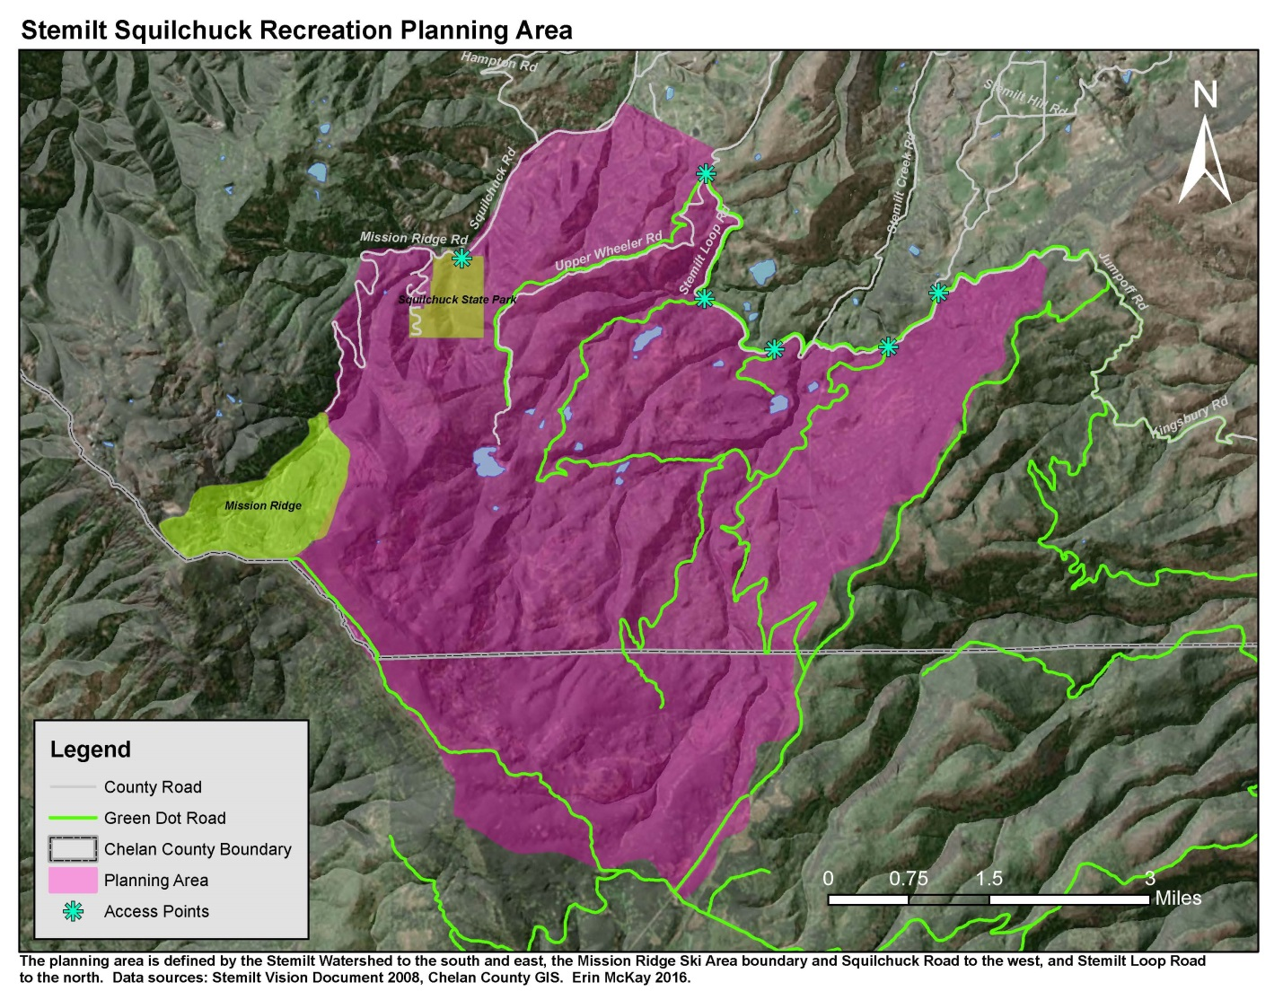

The forested landscape of the upper Stemilt-Squilchuck basin lends itself to a variety of activities including hiking, mountain biking, horseback riding, fishing, hunting and wildlife viewing, skiing and snowshoeing, snowmobiling, and ATV use. Use patterns vary spatially and seasonally in the basin, ranging from summer high use in the lower reaches, to winter motorized recreation in some of the upper reaches, to relatively little use overall in other areas. Access points and dispersed camping areas in the basin are generally not developed, and in some cases are heavily impacted by illegal off-road driving, litter, and erosion to roads and parking areas. While the local community has expressed interest in developing non-motorized summer and winter recreation opportunities, including hiking, mountain biking, horseback riding, and backcountry skiing and snowshoeing, very few non-motorized trails currently exist in the basin. The goal of the recreation planning project is an integrated recreation plan that accomplishes the twin goals of conservation and enhanced recreation opportunity, while also protecting the values of the local community through outreach and a collaborative planning process.

Previous Planning Efforts

The Stemilt Basin falls under the scope of the 2015 Naneum Ridge to Columbia River Recreation and Access Plan. The 2015 plan was a joint effort between WDFW and DNR, and though it is comprehensive and covers a large area, it provides only very broad conceptual ideas for the Stemilt Basin. The proposed planning process will consider the conceptual recreation elements laid out in the 2015 Naneum Plan, but the unique attributes of the Stemilt will require a finer-scale planning process to ensure community support and viability of proposed actions. The combination of checkerboard land ownership, importance of wildlife and water resources, and an invested local community underscores the importance of developing a recreation plan that is specific to the area and is produced through a collaborative process.
The 2008 Stemilt-Squilchuck Community Vision Document also offers guidance for recreation planning in the basin. The Vision Document was produced through an effort between Chelan County, the Trust for Public Land, and the Stemilt Partnership, a coalition of agriculture, wildlife, recreation, development, and conservation interests that formed in 2007 with the goal of preventing privatization of sections of the contiguous upland forest, and planning for the basin with a focus on protecting water resources, conserving critical habitat for fish and wildlife, and maintaining recreational access to public lands (Stemilt-Squilchuck Community Vision, 2008). The Vision Document provides good insight on recreational use and potential, and includes a set of potential recreation development concepts and considerations devised by the Stemilt Recreational Technical Subcommittee during the compilation of the Document. Protection of water resources and wildlife, two of the three pillars of the Vision Document, will play major roles in planning for the third pillar, recreation opportunity in the Stemilt-Squilchuck Community Forest.

Current State of Recreation in the Planning Area

For the purposes of describing the area and initiating a planning strategy, the planning area was divided into zones that exhibit certain characteristics of recreational use and opportunity. These characteristics include use patterns, access, terrain, presence of critical wildlife habitat, and community values. The divisions are based on field observations, WDFW wildlife data, Stemilt Vision Document maps and data, and anecdotal information from local user groups. The County-owned parcels are highlighted in red. This map represents a draft of the zone delineation concept, and can be revised as needed. Zone descriptions are accompanied by photos taken in the field by County staff during the 2016 summer/fall season.

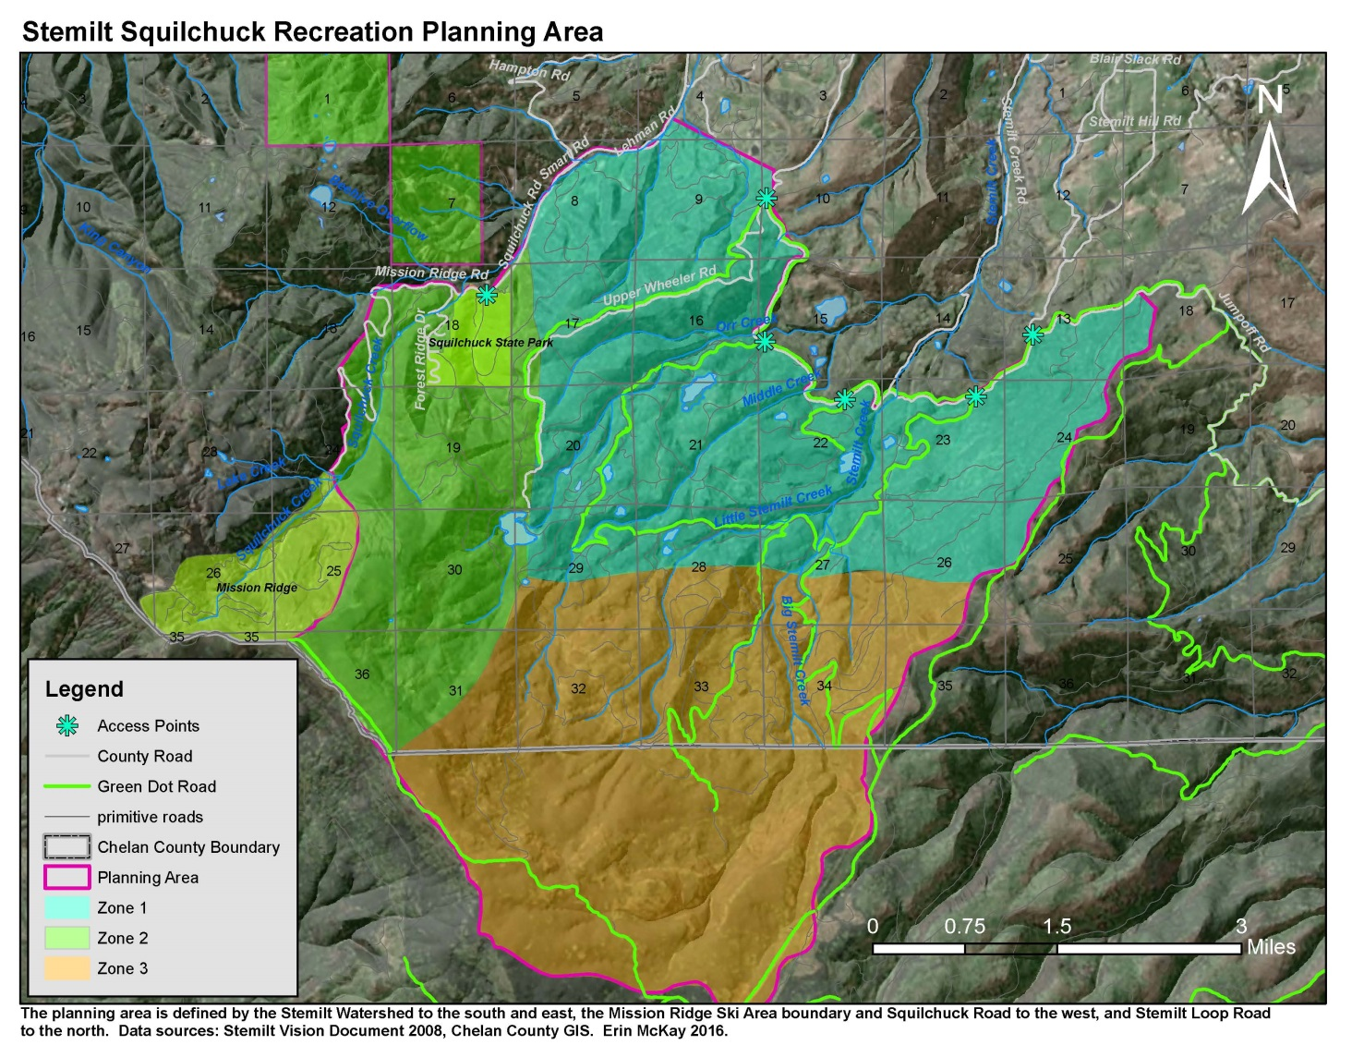
The following map shows critical summer elk habitat in the planning area, based on data from WDFW that was included in the original Community Vision Document. As seen in this map, Zone 1 contains the highest concentration of critical summer elk habitat.

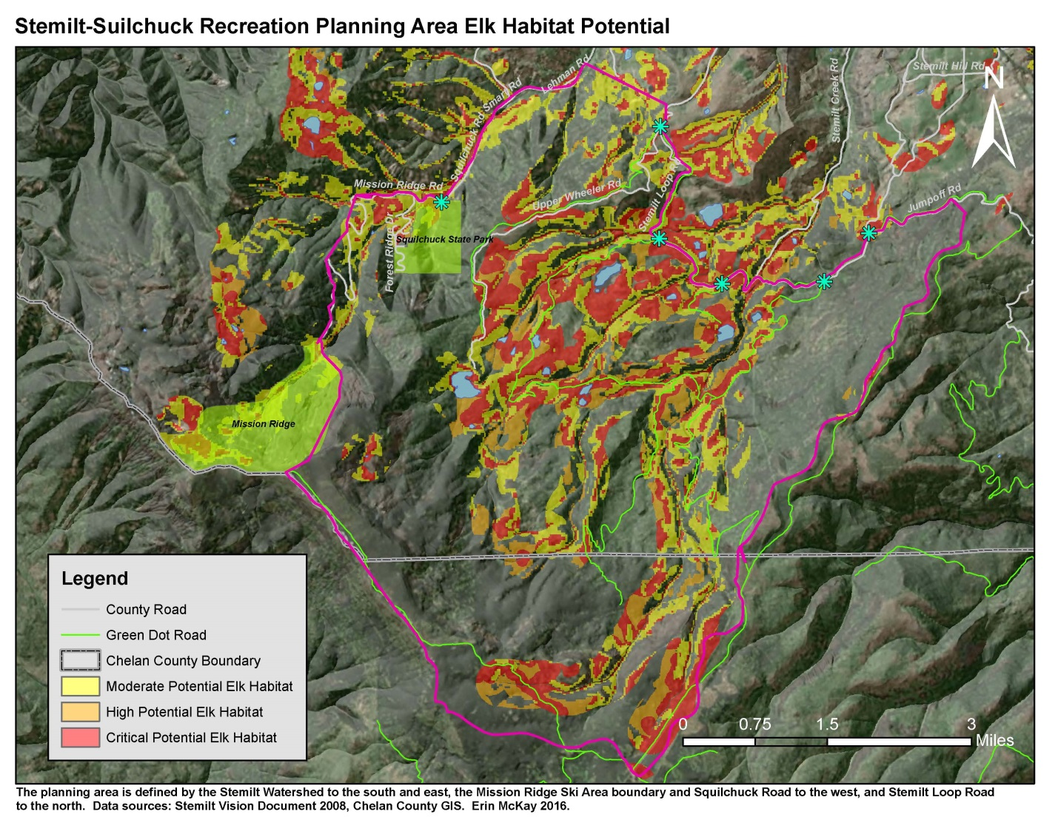

Descriptions of Area by Zone Delineation
Zone 1

-Accessed primarily from Stemilt Loop Road.

-Encompasses Upper Basin Loop Road and associated spur roads, which are part of the Green Dot Road system. These roads provide the main vehicle access into the upper Stemilt basin, and are connected to many other non-Green Dot roads that are technically closed to motorized traffic, but are still used illegally by motorized vehicles. Some of these non-Green Dot roads do have easements for irrigation facility maintenance requiring access, but others could be closed and/or decommissioned. A roads analysis will be an important component to future management of these roads for resource protection and recreation enhancement.

-Gets heavy vehicle use in spring, summer, and fall, and snowmobile use (including an extensive groomed snowmobile trail system) in the winter, with fishing, camping, hunting, wildlife viewing, hiking, horseback riding, recreational driving, and snowmobiling being the main recreational activities taking place.

-Traffic counters installed in 2007 at Green Dot road entrance points into the upper basin show vehicle use increases in the late spring and fall, May being the peak month with 3,073 counts on the Upper Basin Loop Road in May 2007 (Stemilt Vision Document, 2008).

-Contains the majority of the dispersed campsites in the basin, many of which are heavily used in the fall for hunting camps. Many of the impacted campsites occur near water bodies, and are likely used by anglers as well.

-Is visibly affected on some areas by illegal off-roading, trash dumping, large bonfires/impacted campsites.

-Little enforcement of Green Dot Road regulations occurs, although WDFW does occasional patrols in this area. Interest is expressed by WDFW and DNR to improve the Green Dot Road system and find ways to increase compliance.

-Locals (Stemilt Partnership) have expressed interest in more enforcement, hard closures of all non-Green Dot Roads, and restoration projects.

-Locals are also protective of traditional recreational activities in this area.

-Contains private property, WDFW lands, and County lands. Two sections (16 and 22) are technically owned by DNR but are currently transitioning to WDFW ownership.

-This zone contains the highest concentration of critical elk habitat as shown on WDFW data-derived summer elk habitat map.

-Recreation planning focus would likely be on closing or converting illegal roads to non-motorized trails, delineating campsites to reduce dispersed camping impacts, improving access points, and identifying areas for restoration.

-Public input received regarding recreation in this zone includes better equestrian parking and designated equestrian trails, a winter non-motorized trail system, improvements to fishing regulation, designated campsites, designated motorized and non-motorized trails, and better enforcement of Green Dot Road System.

-The County is undertaking a meadow restoration project in an area heavily impacted by vehicle use in a wetland/meadow on the Section 29/28 border, which will involve rerouting a portion of the current Green Dot road out of the meadow area. The County is also working toward a Forest Management Plan for County lands in the upper basin, which will tie in closely with road and recreation management.

Photos of Zone 1:

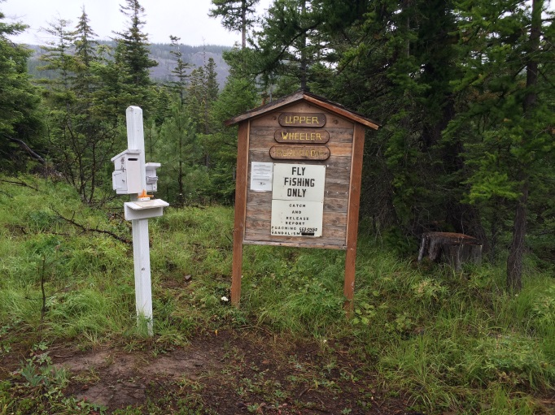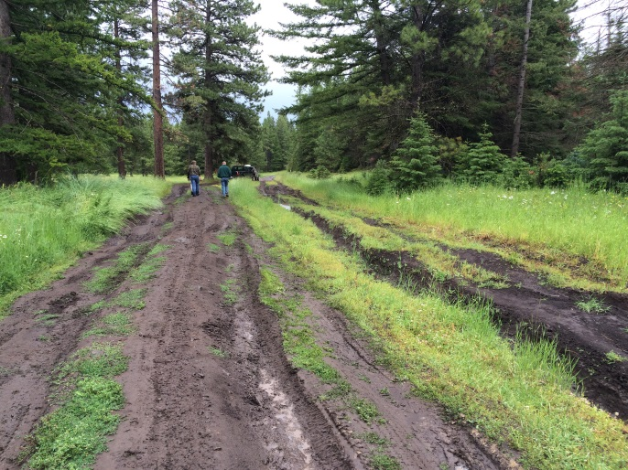
Fishing register at Upper Wheeler Reservoir Meadow damage from vehicles in Steffens Meadow
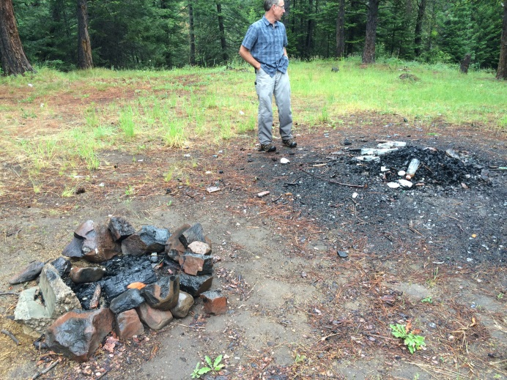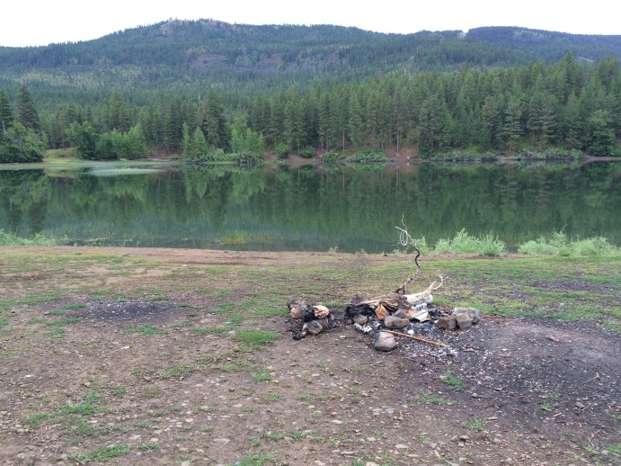
Typical campsite impacts, Steffens Meadow Dispersed campsite at Lily Lake
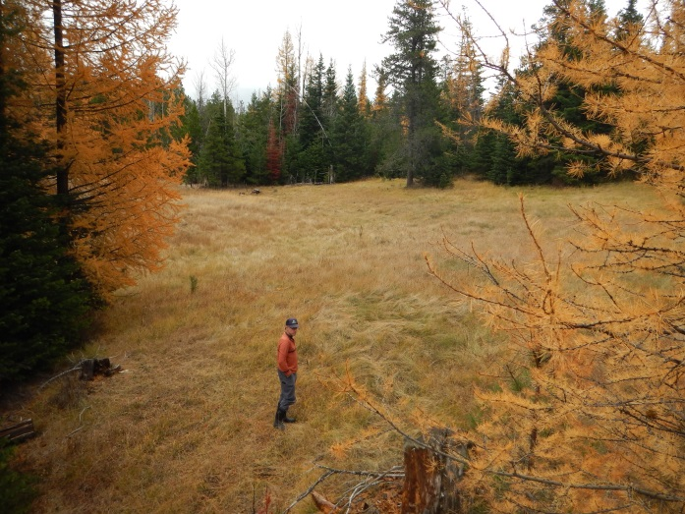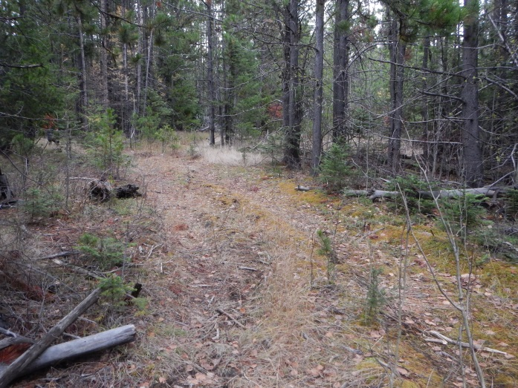
View of a hidden meadow from a tree stand Vehicle impacts from illegal access to hidden meadow
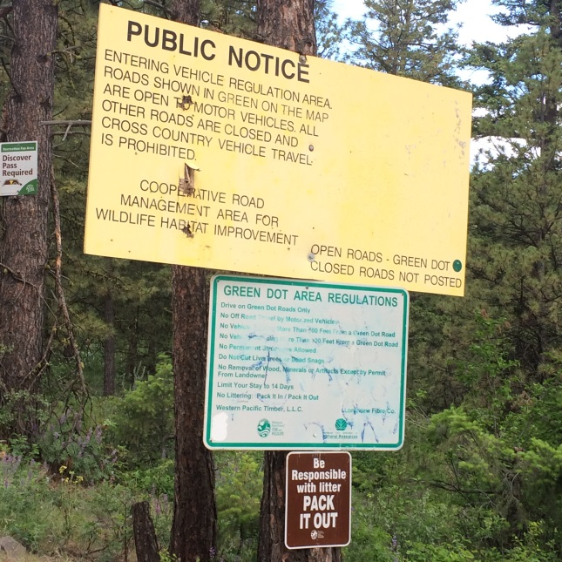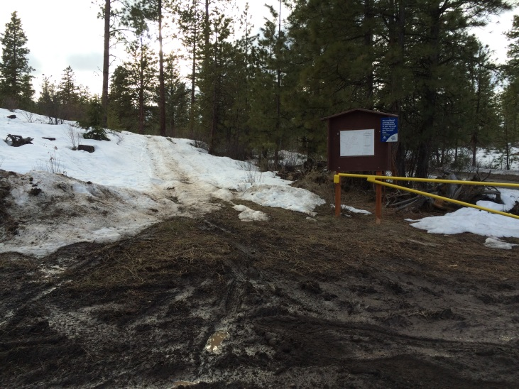
Green Dot road signage at Orr Creek Road Lily Lake access point in spring

Zone 2

-Main access points are from Squilchuck State Park, Mission Ridge Ski Area, Upper Wheeler Road (in very rough condition) and Forest Ridge community off of Squilchuck Road.

-Squilchuck State Park has a newly developed mountain bike trail system that does not currently extend into the Stemilt Basin.

-Mission Ridge Ski Area has purchased Section 19 and the northeast corner of Section 30, and is planning an expansion of ski area operations.

-It is possible to access the Stemilt basin via non-motorized travel on road systems or cross-country from Squilchuck and Mission Ridge, but routes are not well established or signed.

-Local outdoor enthusiasts have expressed interest in access to non-motorized recreation opportunities in this area. The Nanuem Plan and the Stemilt Vision Document also have recreation concepts around non-motorized trail development in this area. The Nanuem Plan specifies development of a non-motorized trail from Squilchuck State Park linking to a non-motorized trailhead in the Naneum State Forest. The Vision Document shows an area marked out as ‘Potential Recreation Expansion Area’ in this zone, with a potential new bicycle route marked out near Upper Wheeler Reservior.

-Most of this area does not fall within the WDFW mapped critical elk habitat, but consultation with a biologist is high priority for development discussions.

-Public input received for this area includes non-motorized trail expansion from Squilchuck State Park into Stemilt basin, possibly linking into Mission Ridge property, nordic skiing trail system, snowmobile access from Forest Ridge into Stemilt basin, better access to back-country skiing in Stemilt basin, fat-tire biking trails in Squlchuck State Park.

-County-owned parcels off of Beehive Road are included in this zone, need to be assessed.

Photos of Zone 2:

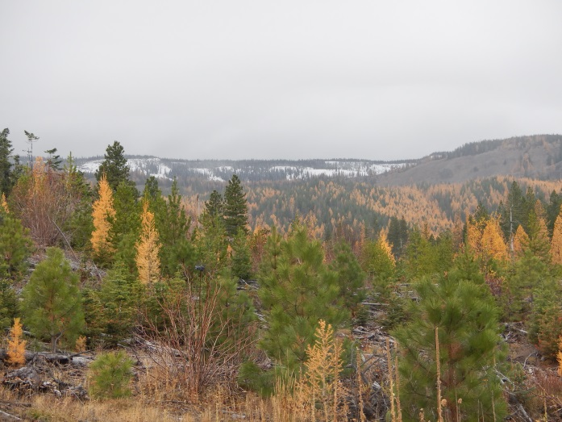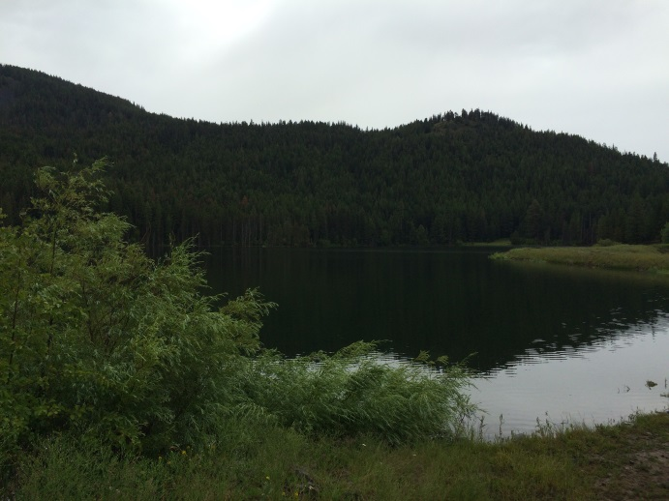
Upper reaches of Stemilt basin, from Section 29 Upper Wheeler Reservoir, wooded ridge in Sec. 30
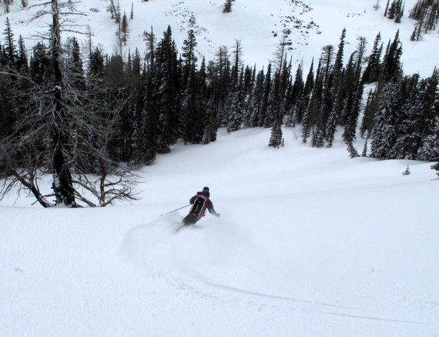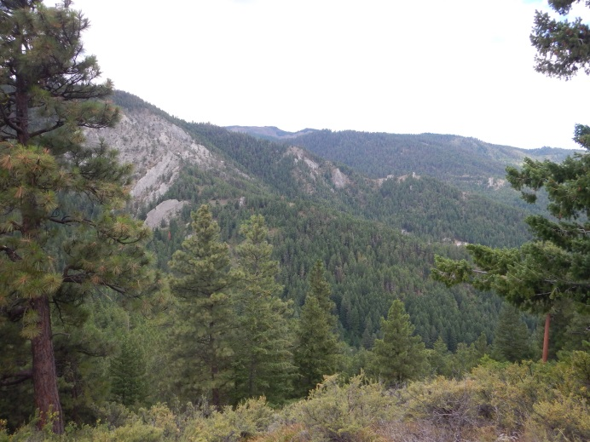
Skier in Upper basin, photo: WenatcheeOutdoors.com Slopes above Squilchuck State Park

Zone 3

-Characterized by rough roads, difficult access, and little in the way of developed recreation resources, this area is primarily used for hunting, snowmobiling, and OHV use. The Schaller Road connects into the Colockum Wildlife Area and Naneum Ridge State Forest, and can be accessed from Ellensburg to the south.

-Public input on recreation development in this area includes a warming hut on the groomed snowmobile trail and a Green Dot road connector that would make Pole Flat road a loop instead of a dead-end.

-The 2007 traffic counter found the highest use of Schaller Road was in October (892 counts), likely due to hunting traffic.

-Land ownership in this area is comprised entirely of WDFW and DNR, and lies within the Colockum Wildlife Area.

-This area primarily sees ‘traditional’ types of recreation (meaning the types of use have not significantly changed over time, and are recreational activities that local families are protective of). This may be a good area to take a ‘keep it like it is’ approach, and consider avoiding further recreational development to avoid user conflicts and protect community values.

-Little is known about recreational use in the eastern reach of the planning area. The County owns a significant portion of the lands in north-eastern part of the basin.

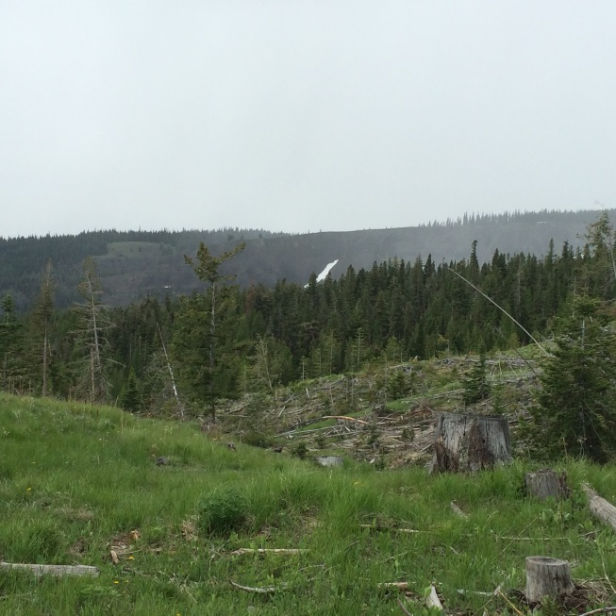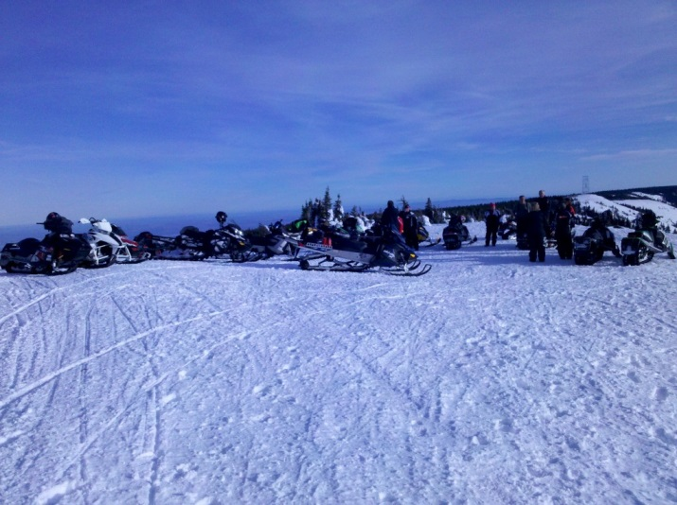
Nanuem Ridge from Schaller Road Snowmobilers atop Naneum Ridge
Photo: applecountrysnowmobileclub.com

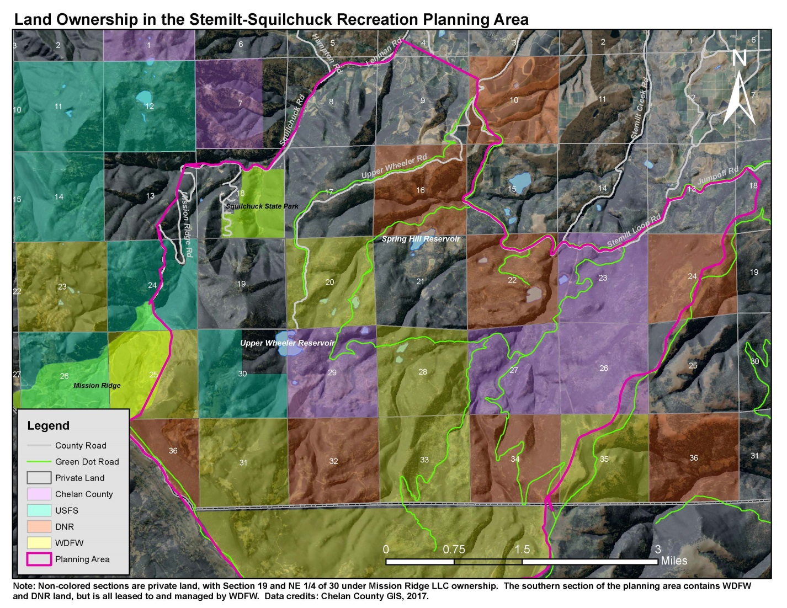
References:
Stemilt-Squilchuck Community Vision. The Trust For Public Land and CORE GIS, Seattle, WA 2008.

